BÀI ÔN TẬP TIẾNG ANH CUỐI TUẦN KHỐI 5
(NGÀY17/02/2021)
Unit 8
Lesson 4+5+6

- BÀI HỌC

Các em viết vào vở mỗi từ, mỗi cấu trúc câu 3 dòng:
I/NEW WORDS
- cage: chuồng
- page: trang sách
- giraffe: hươu cao cổ
- stage: sân khấu
- enormous: khổng lồ
- prepare: chuẩn bị
- worry: lo lắng
- share: chia sẻ
- lazy:lười biếng
II/GRAMMAR

- This bed is good.
- This one is better.
- This one is the best.
- This bed is bad.
- This one is worse.
- This one is the worst.
good better the best

bad worse the worst

B. BÀI TẬP

I. Read and choose the correct answer.

Example: 0. How old are you?, K. I am 9 years old.

1. Who’s this? | A. She goes to school at 6.30
2. What’s her name? | B. Fine, thank you.
3. Is your house big? | C. It’s Lan.
4. Is Mr. Huy an engineer or a doctor? | D. Her name’s Loc.
0. How old are you? | K. I am 9 years old.
5. How are you? | E. We live on Hiep Binh street.
6. Where do you live? | F. She is a nurse.
7. How many students are there in your class? | G. I’m in grade 5.
8. What does your mother do? | H. There are 51.
9. Which grade are you in? | I. He is an engineer.
10. What time does Chau go to school? | J. Yes, it is.

II. Look and Write.

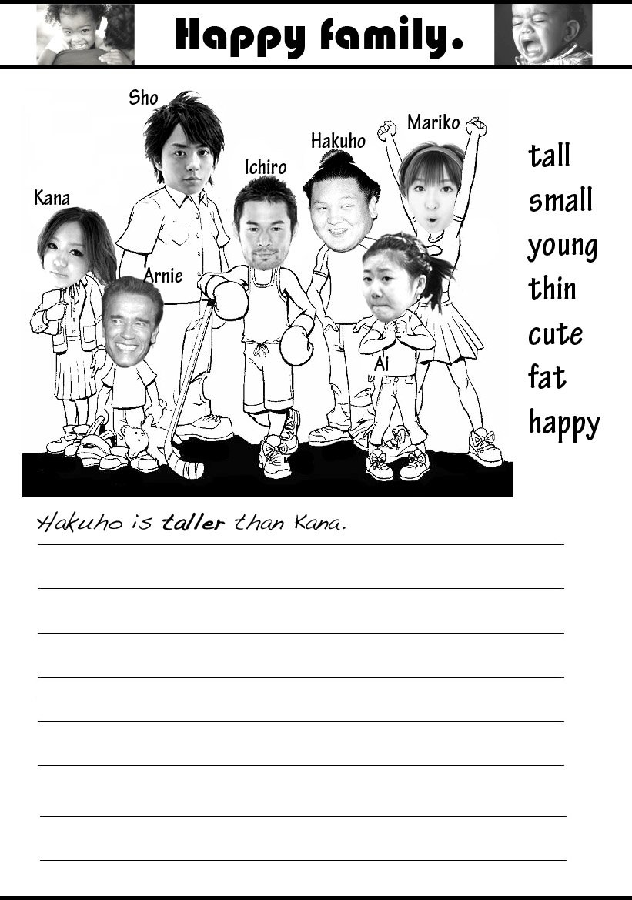

Example: Mariko is taller than Hakuho.

- Sho is the....................................man in the picture.
- Kana is .....................................than Arnie.
- Al is the ...................................girl in the picture.
- Hakuho is ..............................................than Sho
- Ichiro is ...................................................than Hakuho.

ĐÁP ÁNBÀI ÔN TẬP TIẾNG ANH CUỐI TUẦN KHỐI 5
(NGÀY 17/02/2021)
I/
- C
- D
- J
- I
- B
- E
- H
- F
- G
- A

II.
- Tallest
- Younger
- Cutest
- Fatter
- Thinner

