ĐỀ CƯƠNG ÔN TẬP HỌC KỲ II KHỐI 3 NĂM HỌC 2020-2021
UNIT 7: WHERE DOES SHE WORK?
1.Look and write
school police station hospital airport store zoo station bank fire station

 |  | 
……………………………….. | ……………………………….. | ………………………………..
 | 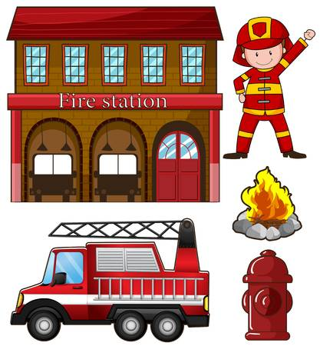 | 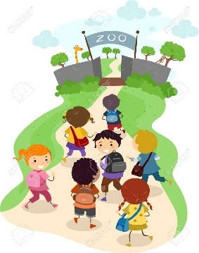
……………………………….. | ……………………………….. | ………………………………..
 | 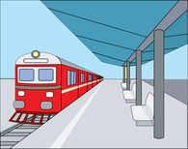 | 
……………………………….. | ……………………………….. | ………………………………..

2. Look and answer .
 | Where does she work ? | She works in a school.
 | Where does she work ? | ……………………………….
 | Where does he work ? | ………………………………
 | Where does he work ? | ………………………………
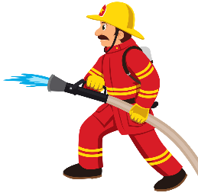 | Where does he work ? | ………………………………
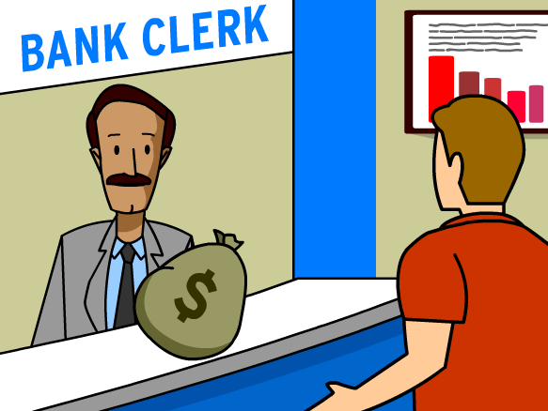 | Where does he work ? | ………………………………
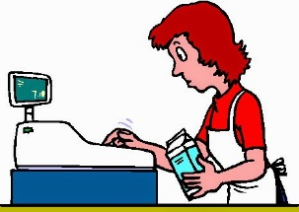 | Where does she work ? | ………………………………

UNIT 8: IT’S HOT TODAY!
1.Look , read and tick () or cross (×)
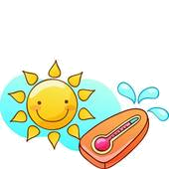
It's sunny.
It's snowing.
It's windy .
It's raining .

It's hot.
It's windy.

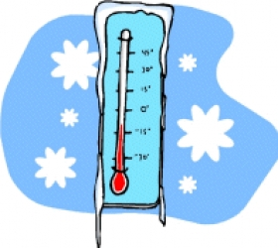
It's raining.
It's sunny.
It's raining.
It's cold.
It's windy .
It's raining.

2.Look at the table above and write sentences , as in the example.
Monday | Tuesday | Wednesday | Thursday | Friday | Saturday | Sunday

Monday : It’s sunny
Tuesday :___________________________________.
Wednesday : ___________________________________.
Thursday : ___________________________________.
Friday: ___________________________________.
Saturday: ___________________________________.
Sunday : ___________________________________.

UNIT 9: WHAT ARE YOU WEARING?
1.Circle the correct word.
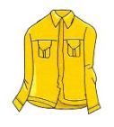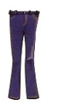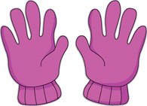

shirt/ skirt

gloves/ jeans

gloves/ scarf

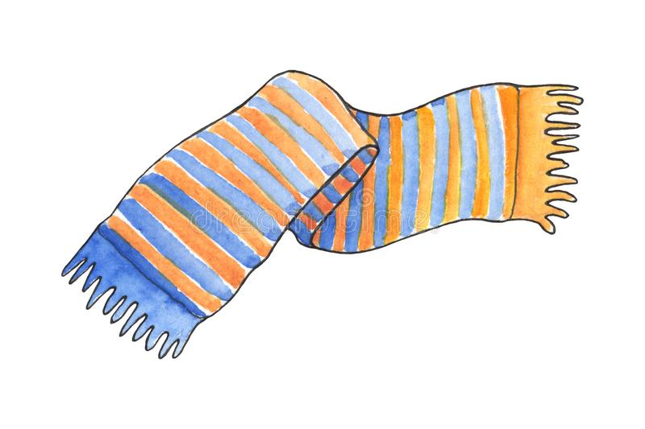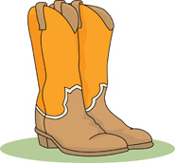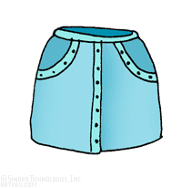

scarf / skirt

shoes / boots

skirt/ dress

2. Read , look and complete. Use the verb to be + wearing.
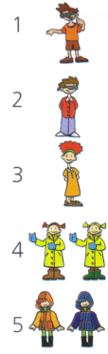
I’m wearing shorts and a T- shirt.
He __________________ pants and a shirt.
She __________________ an orange dress.
We _________________________ yellow coats.
They ___________________ black boots.

3.Look and write.
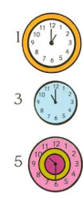 | It is one o’clock.  ………………………………….  …………………………………. | 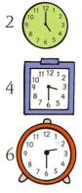 | ………………………………….  ………………………………….  ………………………………….

UNIT 10: YOU’RE SLEEPING.
1.Write
wedding guests bride band invitation cake
INCLUDEPICTURE "https://thumbs.dreamstime.com/t/wedding-guests-group-portrait-flat-vector-concept-smiling-newlyweds-closest-relatives-best-friends-standing-together-88558335.jpg" \* MERGEFORMATINET INCLUDEPICTURE "https://thumbs.dreamstime.com/t/wedding-guests-group-portrait-flat-vector-concept-smiling-newlyweds-closest-relatives-best-friends-standing-together-88558335.jpg" \* MERGEFORMATINET  INCLUDEPICTURE "https://www.colourbox.com/preview/3002423-cartoon-the-bride-and-groom-during-the-wedding-ceremony.jpg" \* MERGEFORMATINET INCLUDEPICTURE "https://www.colourbox.com/preview/3002423-cartoon-the-bride-and-groom-during-the-wedding-ceremony.jpg" \* MERGEFORMATINET 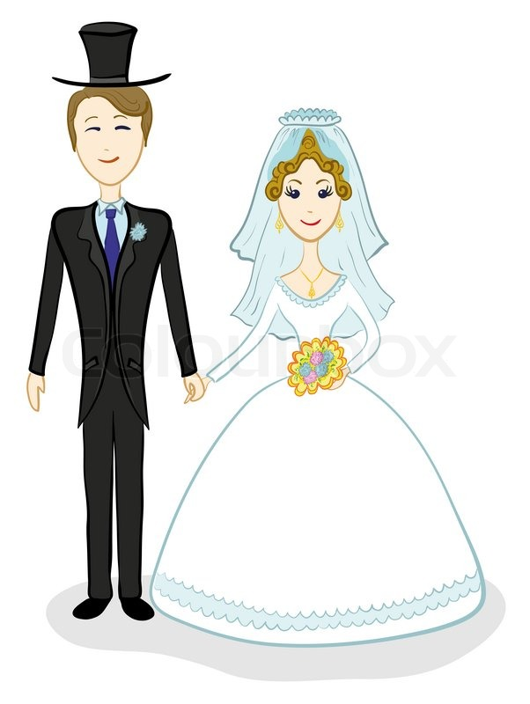 INCLUDEPICTURE "https://i.pinimg.com/originals/2c/63/fc/2c63fcdee5fdfa437ce79b135bc0e67d.png" \* MERGEFORMATINET INCLUDEPICTURE "https://i.pinimg.com/originals/2c/63/fc/2c63fcdee5fdfa437ce79b135bc0e67d.png" \* MERGEFORMATINET 

INCLUDEPICTURE "http://mariafresa.net/newimages/bride-clipart-african-american-18.gif" \* MERGEFORMATINET INCLUDEPICTURE "http://mariafresa.net/newimages/bride-clipart-african-american-18.gif" \* MERGEFORMATINET 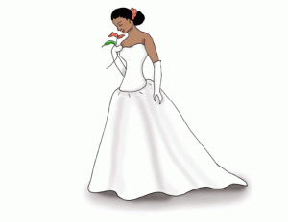 INCLUDEPICTURE "https://sites.google.com/a/d181.org/district-181-beginning-band/_/rsrc/1406142773909/home/-HPu0tQktK_4KP4uxLHoEzCjLyaKpFZq_lJXh8VqTG4.jpeg?height=309&width=400" \* MERGEFORMATINET INCLUDEPICTURE "https://sites.google.com/a/d181.org/district-181-beginning-band/_/rsrc/1406142773909/home/-HPu0tQktK_4KP4uxLHoEzCjLyaKpFZq_lJXh8VqTG4.jpeg?height=309&width=400" \* MERGEFORMATINET 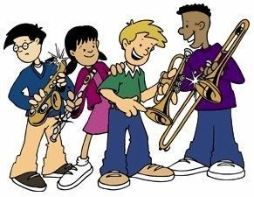 INCLUDEPICTURE "http://www.clker.com/cliparts/P/X/m/x/G/J/invitation-hi.png" \* MERGEFORMATINET INCLUDEPICTURE "http://www.clker.com/cliparts/P/X/m/x/G/J/invitation-hi.png" \* MERGEFORMATINET 

2.Complete the sentences with the correct form of the verb in brackets.
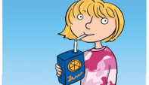 | 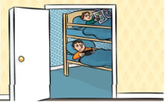 | 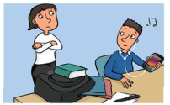
I’m drinking (drink) | They _____________(not sleep ) | You _____________(not study )
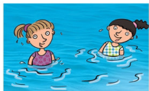 | 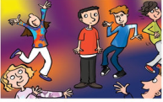 | 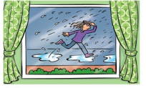
We ________________(swim) | He_______________ (not dance) | It ______________(rain)

UNIT 11: LOOK AT ALL THE ANIMALS!
1.Fill in the blanks.
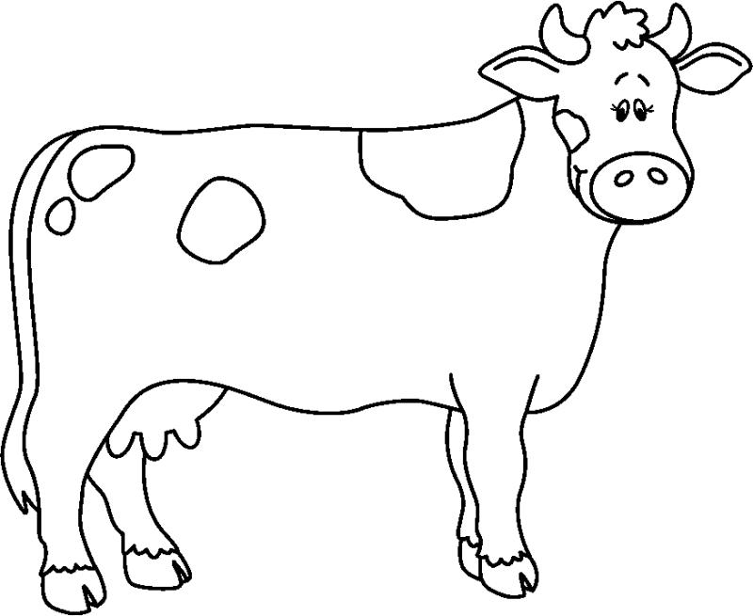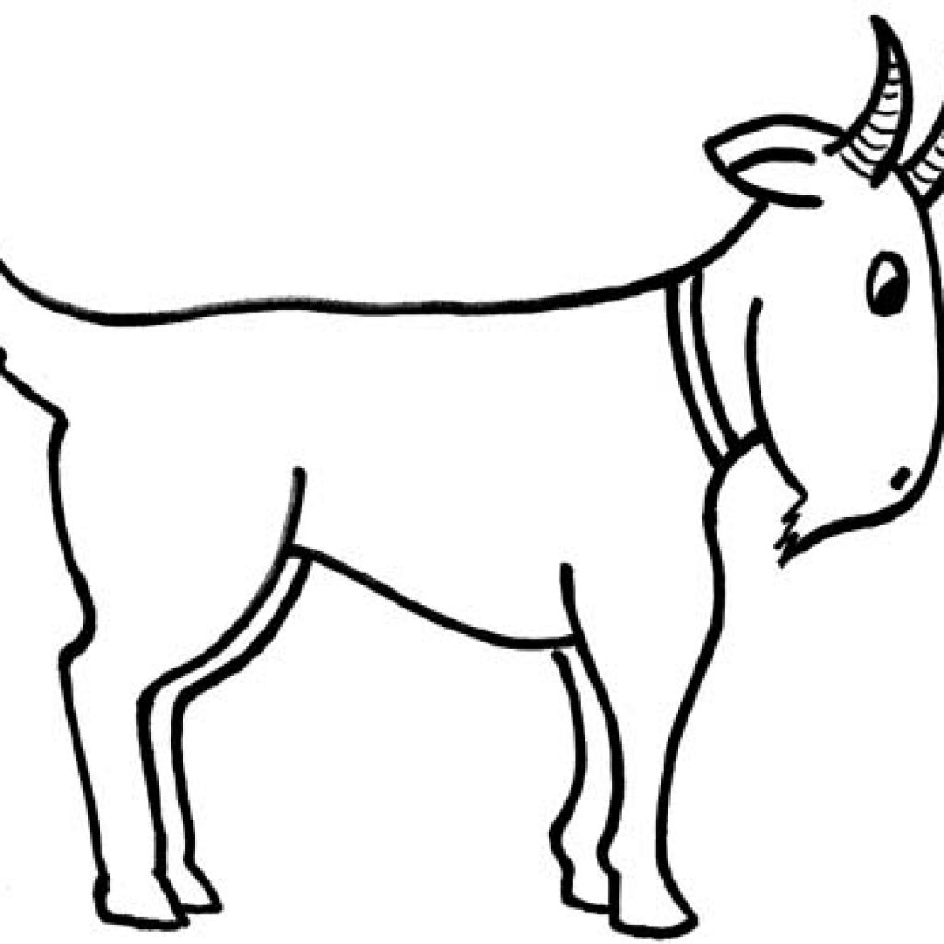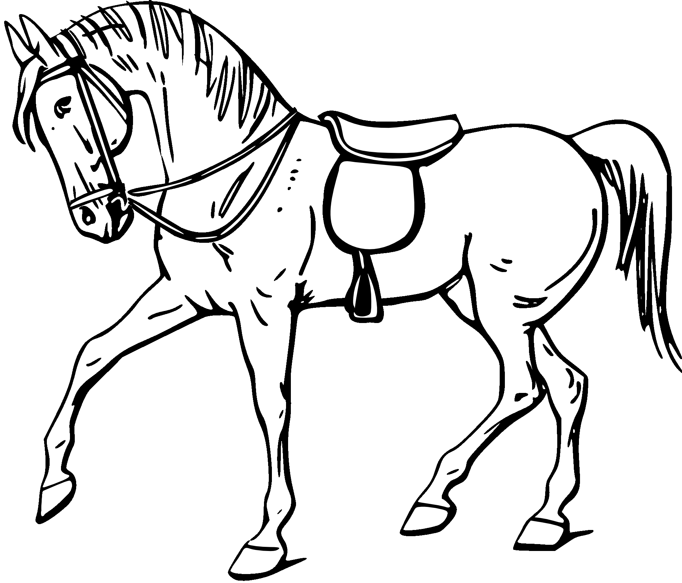
c _____ w
g _ _ t
_ _ r_ e

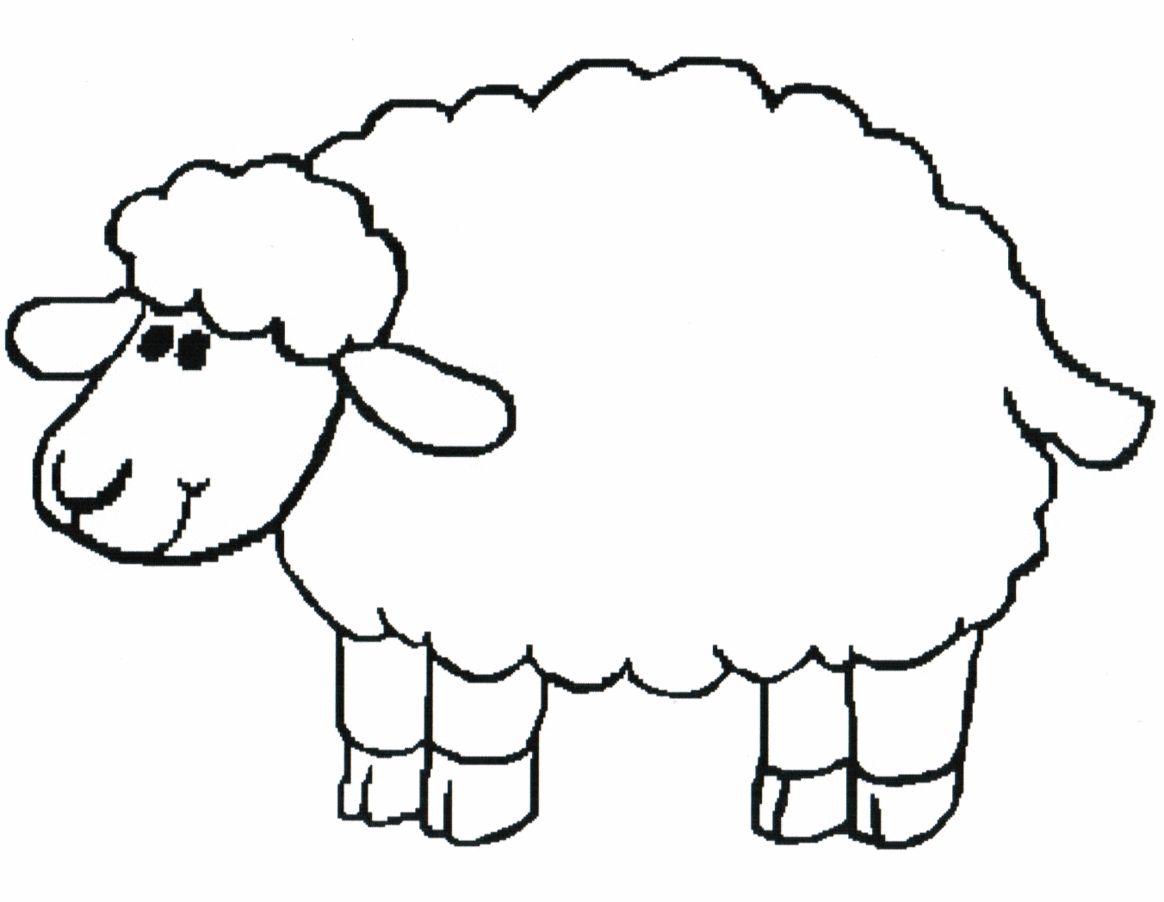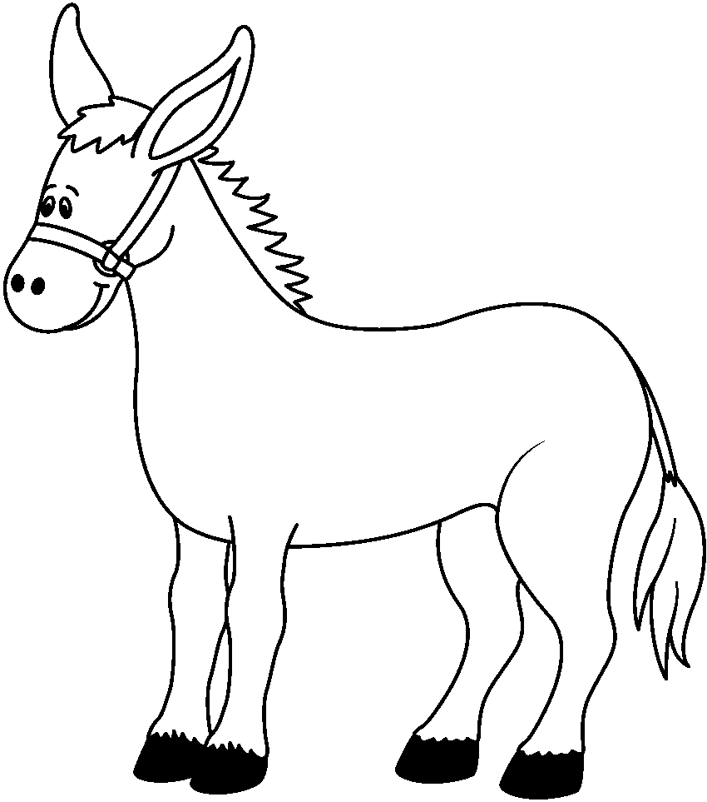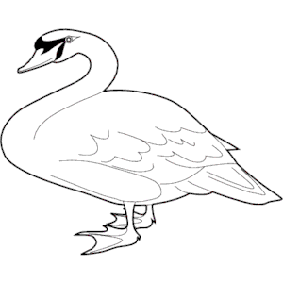
she _ p
_ on _ e _
goo _ _

2. Circle the correct word.

- The whale is bigger / smaller than the shark


- The fish is taller/ smaller than the shark.


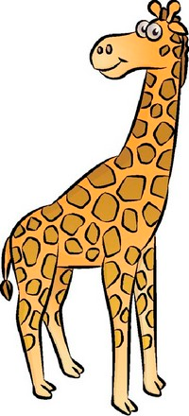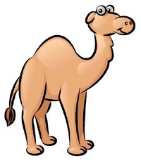

- The giraffe is shorter/ taller than the camel.

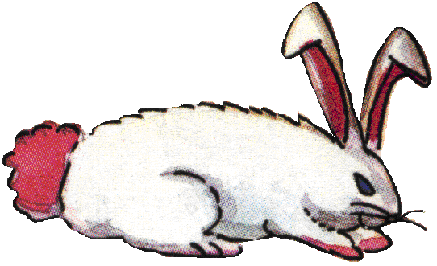

- The cheetah is faster/ smaller than the rabbit.

-The tortoise is faster/ slower than the rabbit.


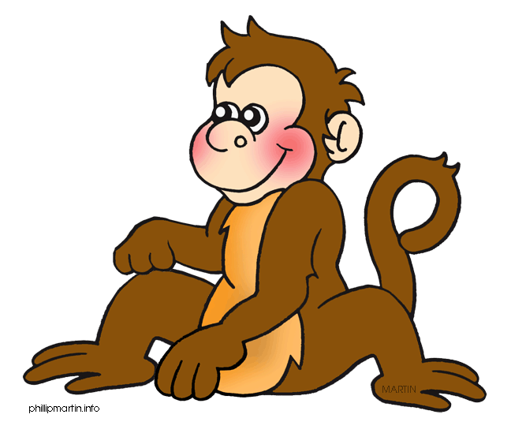

- The monkey is noisier/ quieter than the bird.

- The fish is noisier/ quieter than the bird.


UNIT 12: LOOK AT THE PHOTOS!
1.Circle the correct option :
We was / were tired last night .
a. I wasn’t /weren’t at school last week.
b. You was /were very kind yesterday.
c. It was / were cold last night .
d. My parents was / were at the supermarkets this morning.
e. David wasn’t / weren’t happy yesterday.
f. We was / were late this morning.
g. My friends wasn’t / weren’t in the park this afternoon.
h. She was /were at home all day today.
2. Copy the adjectives (tính từ):
Long: dài Short: ngắn
Black: đen White: trắng
Tall: cao Short: thấp
Big: lớn Small: nhỏ
Loud: ồn ào Quiet: yên tĩnh
Fast: nhanh Slow: chậm
Wet: ướt Dry: khô
Good: tốt Bad: xấu
Happy: vui vẻ Sad: buồn
Hot: nóng Cold: lạnh
Hungry: đói Thirsty: khát
Neat: gọn gàng Messy: bừa bộn

-----HẾT-----

