**UNIT 1: What color is it?**

**EXERCISES**

**Exercise 1: Copy the words.**

**red red red red red red red red red red**

**red**

**red**

**red**

**green**

**blue**

**black**

**white**

**cat**

**car**

**dog**

**duck**

**three**

**four**

**Exercise 2: Look and write the missing letters.**

|  |  |  |  |  |
| --- | --- | --- | --- | --- |
|  | Káº¿t quáº£ hÃ¬nh áº£nh cho white  clipart |  | Káº¿t quáº£ hÃ¬nh áº£nh cho black   clipart |  |
| blu _ | w _ ite | gr _ _ n | _ lack | r _d |

**Exercise 3: Read and color.**







It’s black.

It’s red.

It’s blue.







It’s white.

It’s yellow.

It’s green.

**Exercise 4: Look and match.**

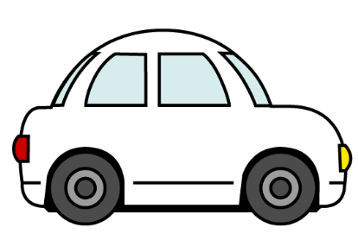



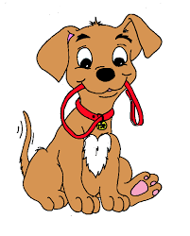

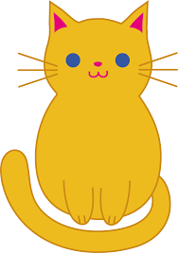

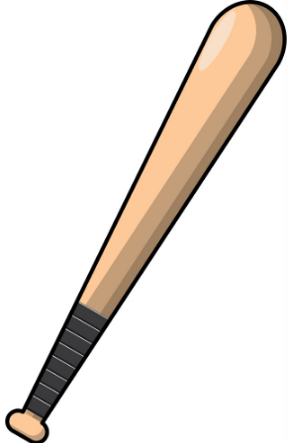



A

B

C

D

**Exercise 5: Look and write the missing letters.**

|  |  |  |  |
| --- | --- | --- | --- |
|  |  |  |  |
| **c**at | _ pple | _ at | _ ar |
|  |  |  |  |
| _ og | _ oy | _ uck | Bi _ _ y |

**Exercise 6: Look and write.**

|  |  |  |  |
| --- | --- | --- | --- |
| two | three | four | one |

|  |  |  |  |
| --- | --- | --- | --- |
|  |  |  |  |
| *four* | ………………………. | ……………… | ……………… |

**Exercise 7: Color by numbers.**

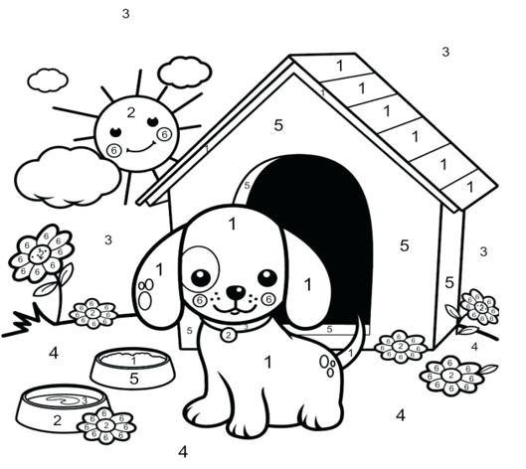

|  |  |  |  |  |  |
| --- | --- | --- | --- | --- | --- |
| 1 = black | 2= yellow | 3= blue | 4 = green | 5 = red | 6 = pink |