Name: ________________________ Năm học 2019 - 2020
Class: ____
BÀI LUYỆN TẬP TIẾNG ANH KHỐI 4
Unit 8: I’d like a melon!
Grammar
- Choose a/an/some. Write the words in the correct boxes.
egg lemon orange banana meat cereal noodles apples pastry onion cucumber rice garlic bean sprouts melon bread sauce lemons mushrooms

Uncountable Noun

Countable Noun

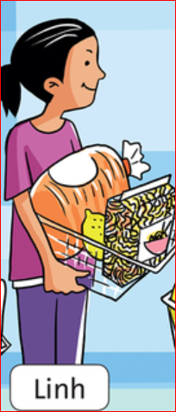
- Look at the picture and complete the sentence.
- Linh’d like ________ _________.
- She’d like ________ _________.
- She’d like ________ _________.

- Look at the picture and write “ True or False”
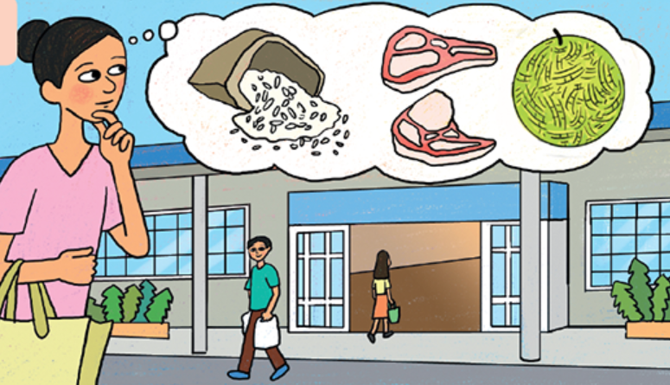

- She’d like some rice. ____________
- She’d like some lemons. ____________
- She’d like an apple. ____________
- She’d like a pear. ____________
- She’d like some meat. ____________
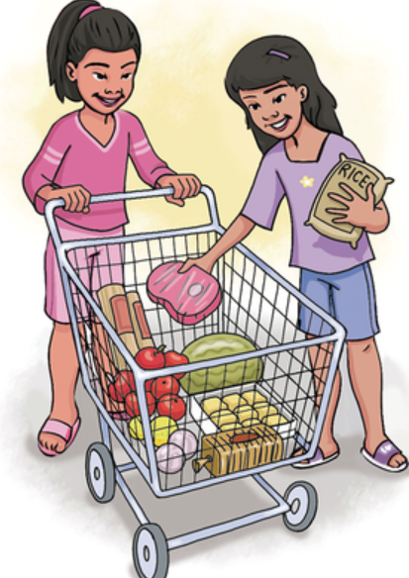
- Look at the picture and answer the question “What would they like?”
They’d like ……………………………..
…………………………………………..
…………………………………………..
…………………………………………..
…………………………………………..
…………………………………………..
- Answer the question about yourself.
- Would you like some noodles?
……………………………………
- What would you like?
……………………………………

Địa chỉ mail thầy Sơn Anh Văn: tnhson86@gmail.com
Địa chỉ mail cô Hạnh Anh Văn: hanh_hoabinh@live.com

