REVIEW UNIT 7,8,9,10
- Write his or her.
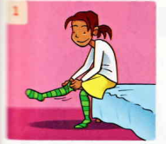 | 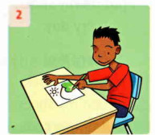 | 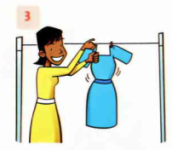
These are_________socks. | This is _______T-shirt. | This is _________ dress.

Match

1.Where is she ? | a. Yes , she is.
2.Is she in the kitchen ? | b. She is in the bedroom.
3.Where are they ? | c. No , they aren’t.
4.Are they in the living room ? | d. They are in the living room.
5.Is he in the bedroom ? | e. I am in the kitchen.
6.Where is he ? | f. No , he isn’t.
7.Where are you ? | g. He is in the bathroom.

Put the words in the correct order to make sentences.

- I / have /an /apple./ ________________________________________
- an/orange./ I /have/________________________________________
- two/ pears./ I have/________________________________________
- lunchbox./ I have/ /a ________________________________________
- I /have/don’t/ a / drink./________________________________________
- have/some / grapes./ I /______________________________________________
- Complete the sentences.
- Does she have black hair ? Yes , he ____________________.
- Does he have blue eyes ? No , ___________________.
- _______ she have long hair ? Yes ,she does.
- Does she have long hair ? ____________,she doesn’t
- _________ he have curly hair ?No , _________________.
- ___________ she have big eyes ? Yes , she _______________.

