**Name: ___________________ Class: ­­­­­­­­­­­­­­­ __________**

Exercise 1: Match.

1. Hello a. I’m seven.
2. How are you? b. Hi
3. What’s your name? c. Bye
4. How old are you? d. I’m fine, thank you.
5. Goodbye e. My name’s Jasmin.

Exercise 2: Write

|  |
| --- |
| Her His He’s She’s |

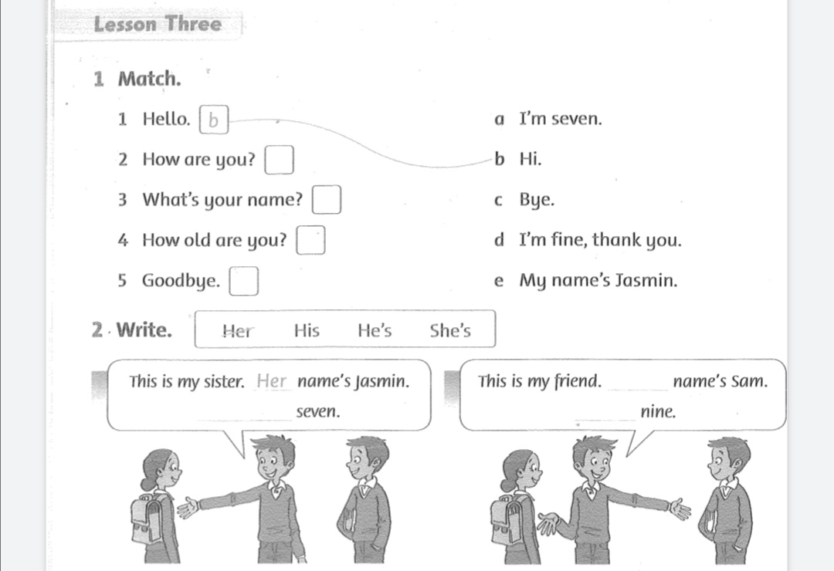

Exercise 3: Find and circle the days of the week. Write

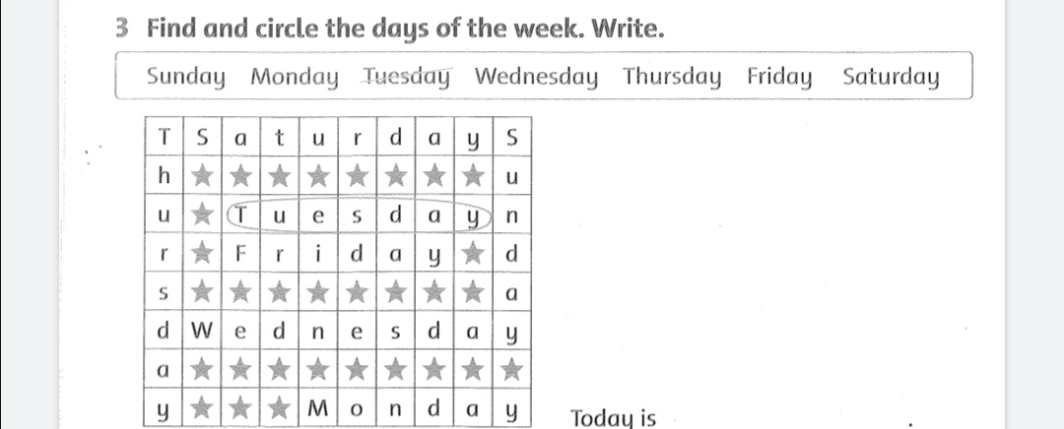

Exercise 4: Look at the picture. Count and write:

|  |
| --- |
| There is There are |

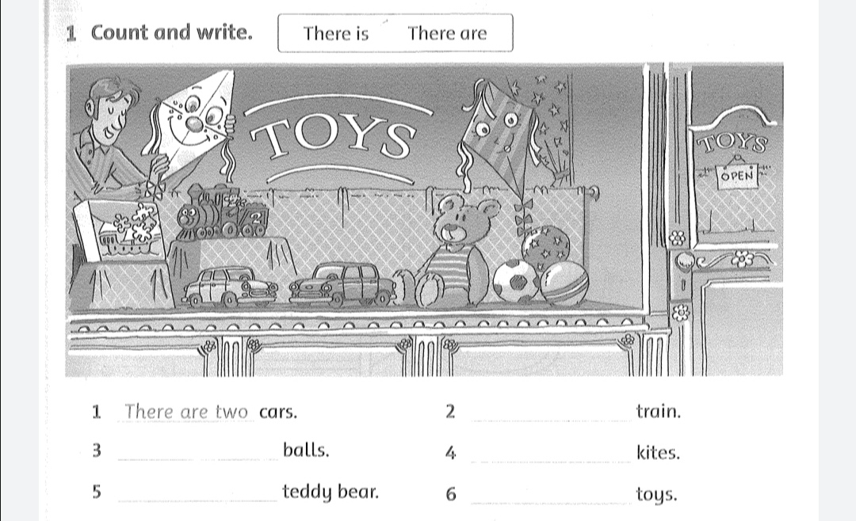

Exercise 5: Write the missing word or number:

