**Name: ___________________ Class: ­­­­­­­­­­­­­­­ __________**

Exercise 1: Listen and draw lines:

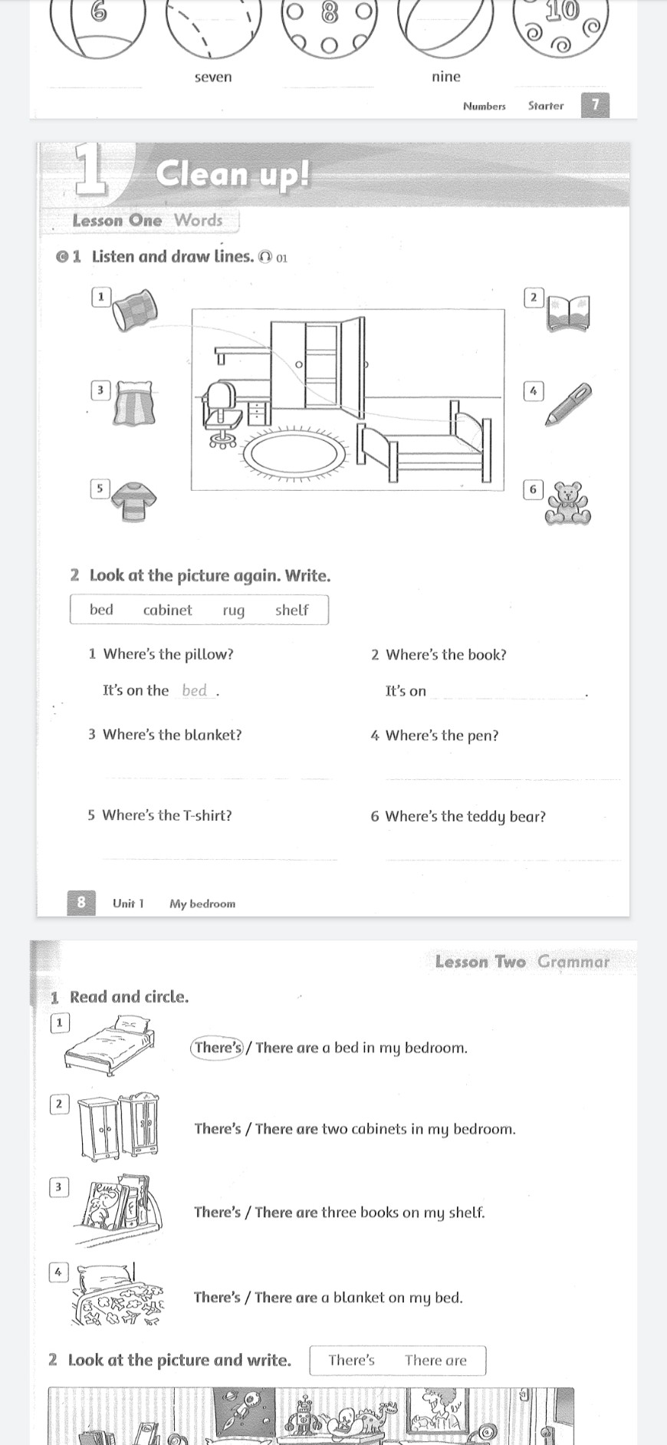

Exercise 2: Look at the picture again. Write.

1. Where’s the pillow?

It’s on the bed.

1. Where’s the book?

It’s on ………………………………………

1. Where’s the blanket?

……………………………………………….

1. Where’s the pen?

……………………………………………….

1. Where’s the T-shirt?

………………………………………………..

1. Where’s the teddy bear?

………………………………………………..

Exercise 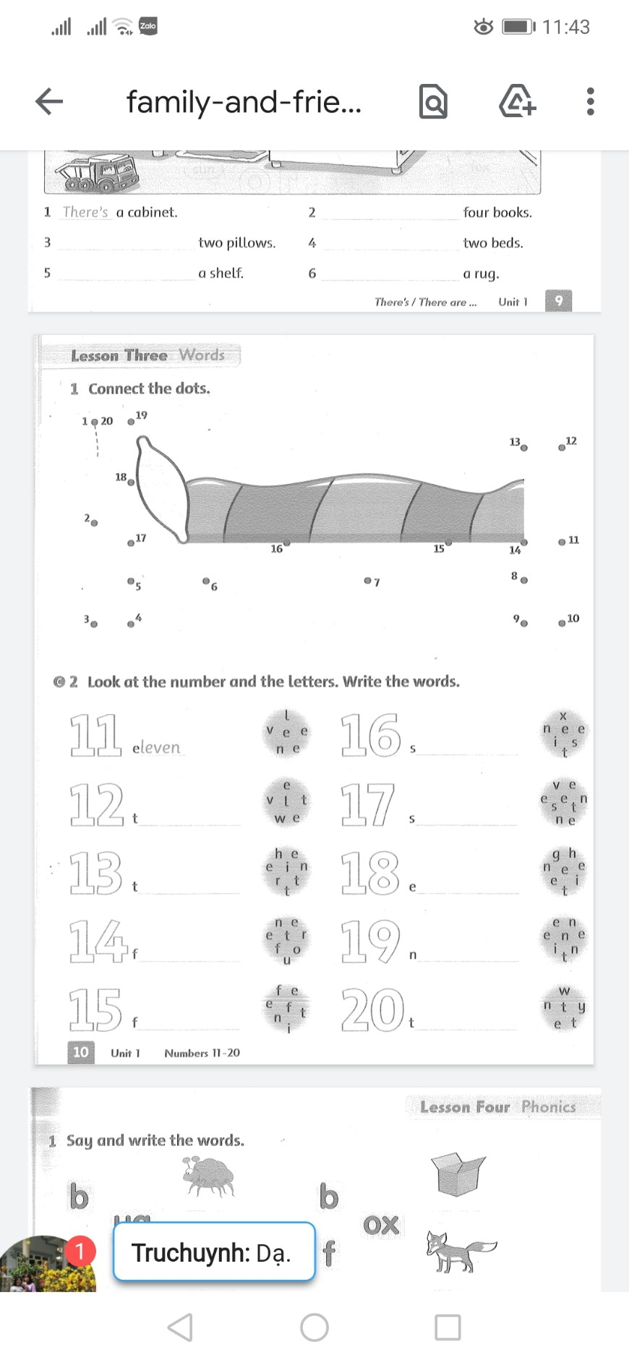3. Connect the dots.

Exercise 4. Look at the number and the letters. Write the words

