**BÀI ÔN TATC KHỐI 4 LẦN 5**

**TUẦN TỪ 30/3 ĐẾN 3/4/2020**

1. **Find the words**

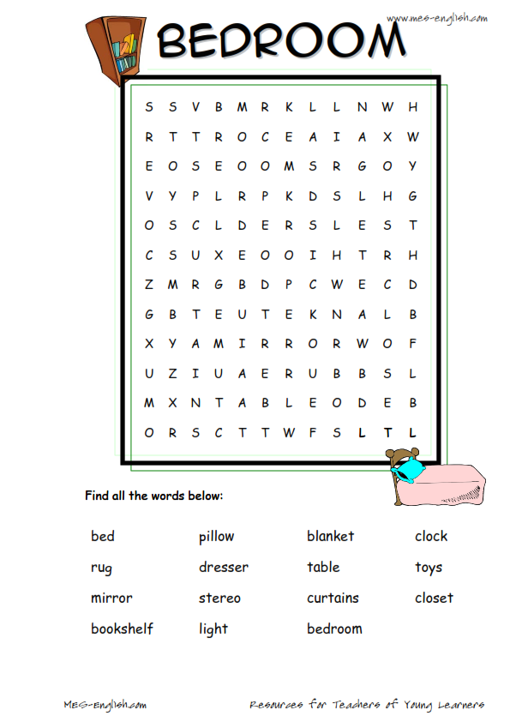

1. **Look at the pictures and write the words**

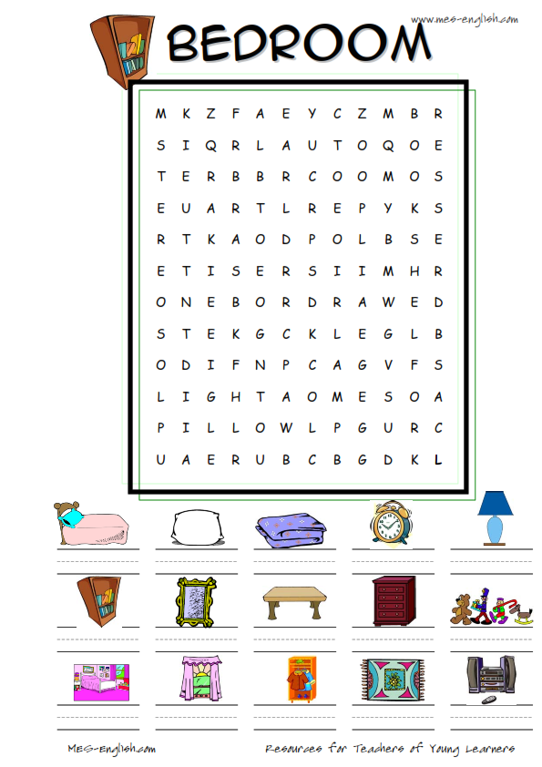

Copy:

|  |  |  |  |  |  |  |  |
| --- | --- | --- | --- | --- | --- | --- | --- |
| Image result for curtain cartooncurtains | …………………… | | | …………………… | | …………………… | |
| …………………… | | | …………………… | | …………………… | |
| …………………… | | | …………………… | | …………………… | |
| Image result for closet cartoon  closet | | …………………. | …………………. | | …………………. | |
| …………………. | …………………. | | …………………. | |
| …………………. | …………………. | | …………………. | |

|  |  |  |  |
| --- | --- | --- | --- |
| dresser | ………………… | ………………… | ………………… |
| ………………… | ………………… | ……………… |
| ………………… | …………………… | …………………… |

1. **Look and read. Choose the correct words and write them on the lines.**

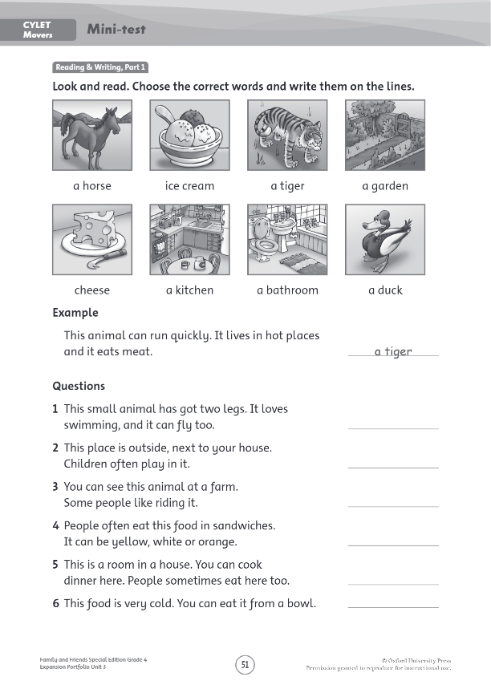

1. **Match the beginings and the ends of the questions.**

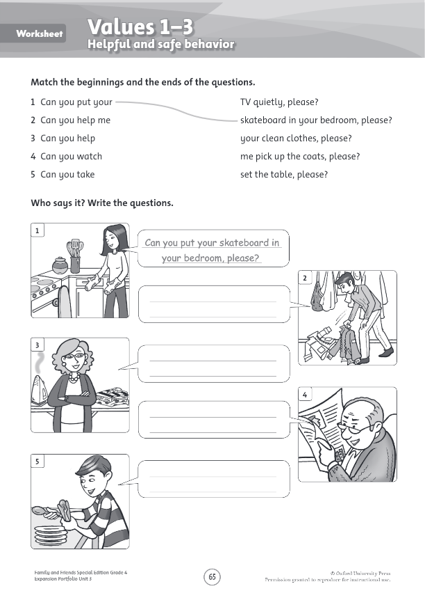

1. **Look at exercise 4. Write questions.**



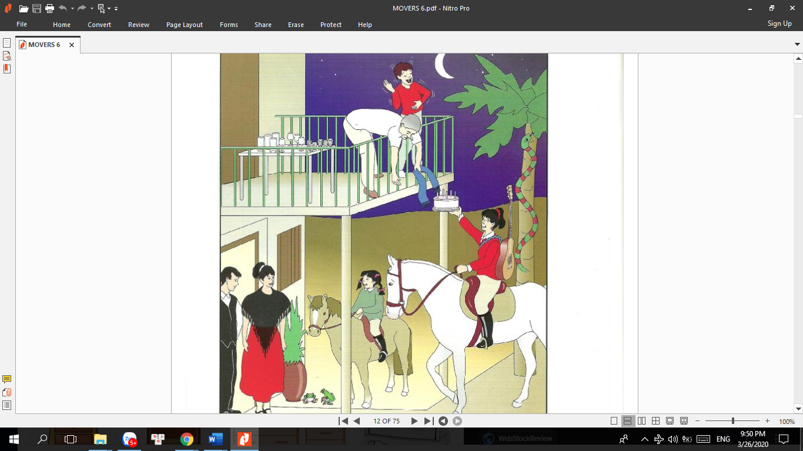

1. **Look at the picture and write:**
2. The snake is ……………………………..the tree.
3. There are ……………………………..on the balcony.
4. The girl with a guitar is ………………………………..
5. The man on the balcony is taking ………………………….
6. A man and a ………………are standing by the door.