UBND THÀNH PHỐ THỦ ĐỨC
TRƯỜNG TH NGUYỄN VĂN BANH

TUẦN 34
REVIEW 2 - UNIT 4,5,6

I. Read and circle:

- 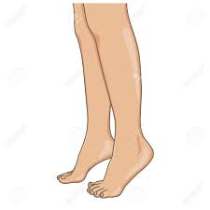  legs |   face
-   cookies | 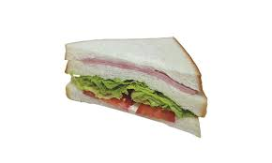  a sandwich
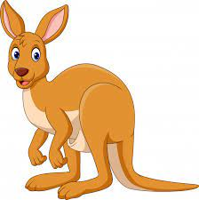  kangaroo |   a tiger
  a banana | 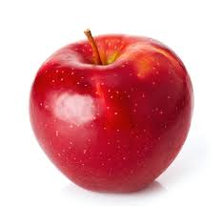  a pear

II. Count and circle
  1.  two / one |   2.  three / two |   3.  seven / nine | 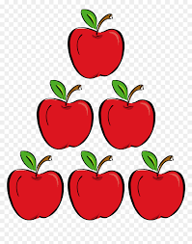  4.  five / six

III. Read and match
  1. | a hippo
  2.  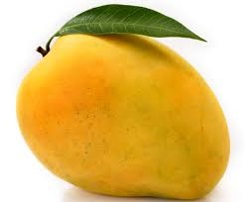 | water melon
3. | a nose
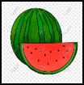  4. | a mango
IV. Look and read. Put a tick () or a cross (x) in the box
  1. | It’s a tiger.
  2. | They’re fingers.
3.  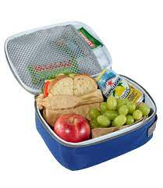 | I have a sandwich.
4. | I have a cookie.

