Exercise 1 Circle the correct word:
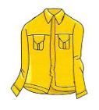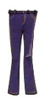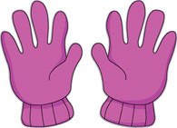

shirt/ skirt

gloves/ jeans

gloves/ scarf

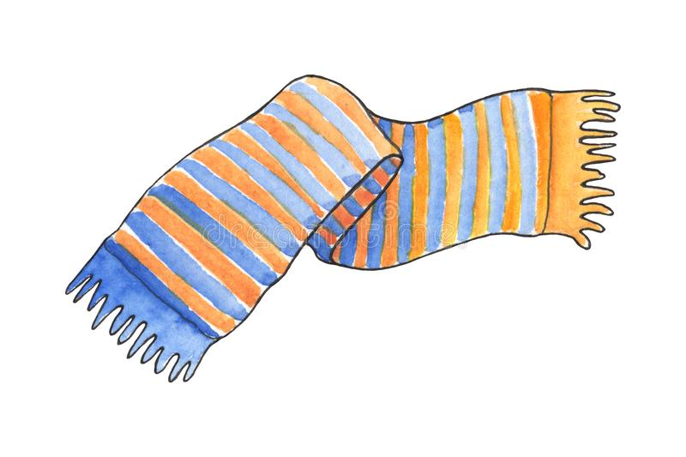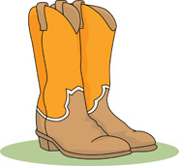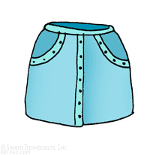

scarf / skirt

shoes / boots

skirt/ dress

Exercise 2 Put the words in the correct order
a. He /wearing / green/ a /T-shirt./ is/
………………………………………………………………………………………..
b. is/ Amy / black / trousers. / wearing /
………………………………………………………………………………………..
c. I / wearing / dress./ a/ pink/am
………………………………………………………………………………………..
d. She / is /wearing / blue / shirt./ a/
………………………………………………………………………………………..
e. He / wearing / is /green / gloves./
………………………………………………………………………………………..
f. boots ./ My / sister / wearing / is/ brown/
………………………………………………………………………………………..
g. My / jeans ./dad/ is / wearing / blue/
………………………………………………………………………………………..
h. scarf. / She /wearing / is / yellow/a/
………………………………………………………………………………………..
i. They / boots. /are /wearing / grey
………………………………………………………………………………………..
j. He / wearing / blue /is/ shoes./
………………………………………………………………………………………..
k. are / you /What / wearing ?
………………………………………………………………………………………..
l. My sister / coat / is /wearing / a/ yellow
………………………………………………………………………………………..
m. She / skirt / is / wearing / a / green
………………………………………………………………………………………..
n. is /What / he /wearing ?
………………………………………………………………………………………..

