**REVIEW UNIT 12**

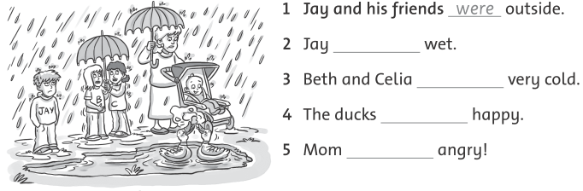**1. Complete: was - were**

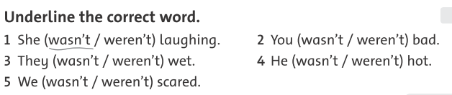**2. Underline the correct word.**

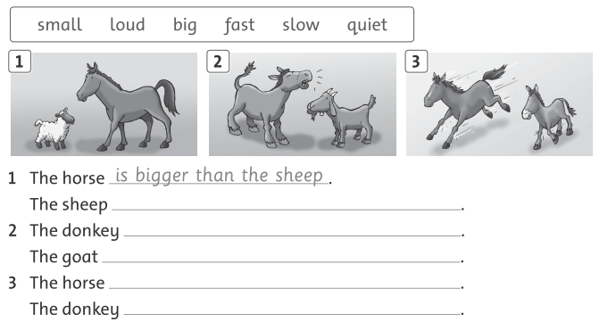**3. Write. Use “than” and a comparative adjective.**

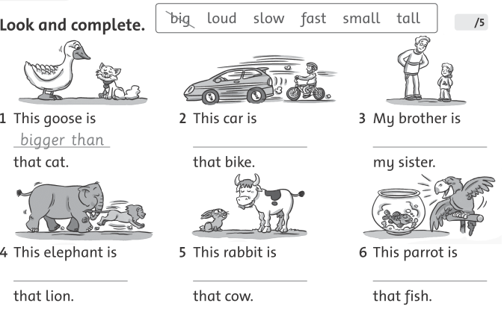**4.** 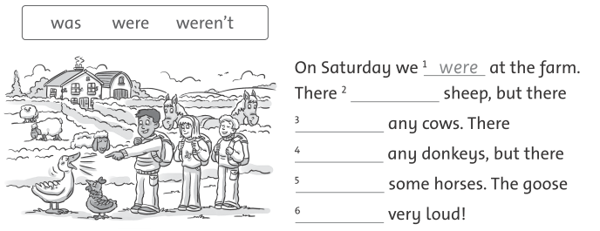

**5. Complete.**

**ANSWER KEY**

1. **Complete: was – were**

2.was 3. were 4. were 5. was

**2. Underline the correct word.**

2. weren’t 3. weren’t 4. wasn’t 5.weren’t

**3. Write. Use “than” and a comparative adjective.**

1. The sheep is smaller than the horse.

2. The donkey is louder than the goat.

The goat is quitter than the donkey.

3. The horse is faster than the donkey.

The donkey is slower than the horse.

**4. Look and complete.**

2. faster than 3. taller than 4. slower than

5. smaller than 6. louder than

**5. Complete.**

2. were 3. weren’t 4. weren’t 5. were 6. was