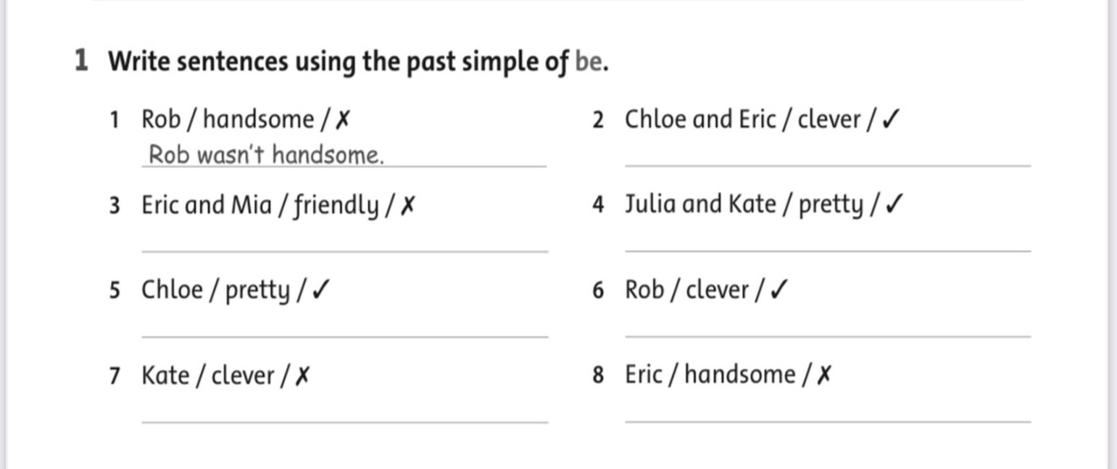
REVIEW UNIT 12
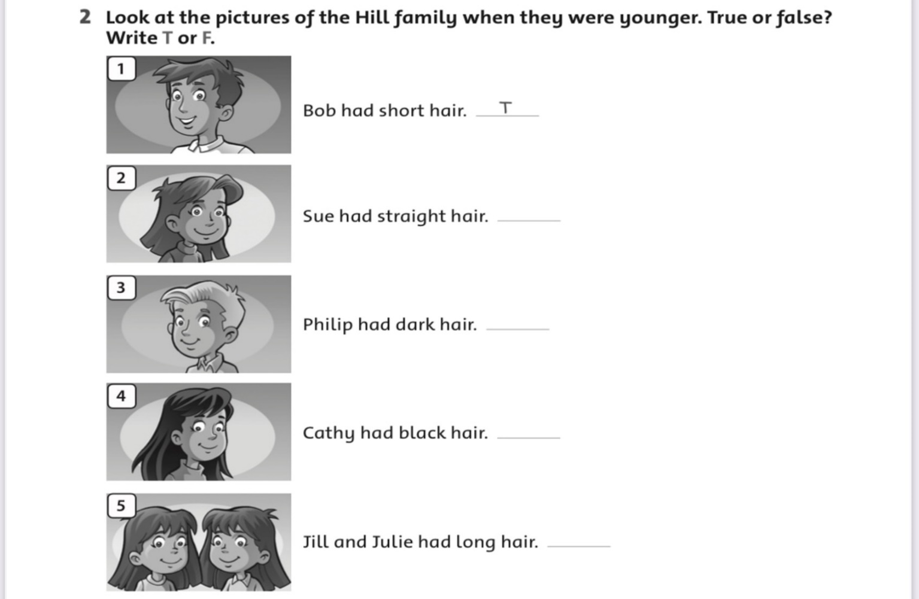

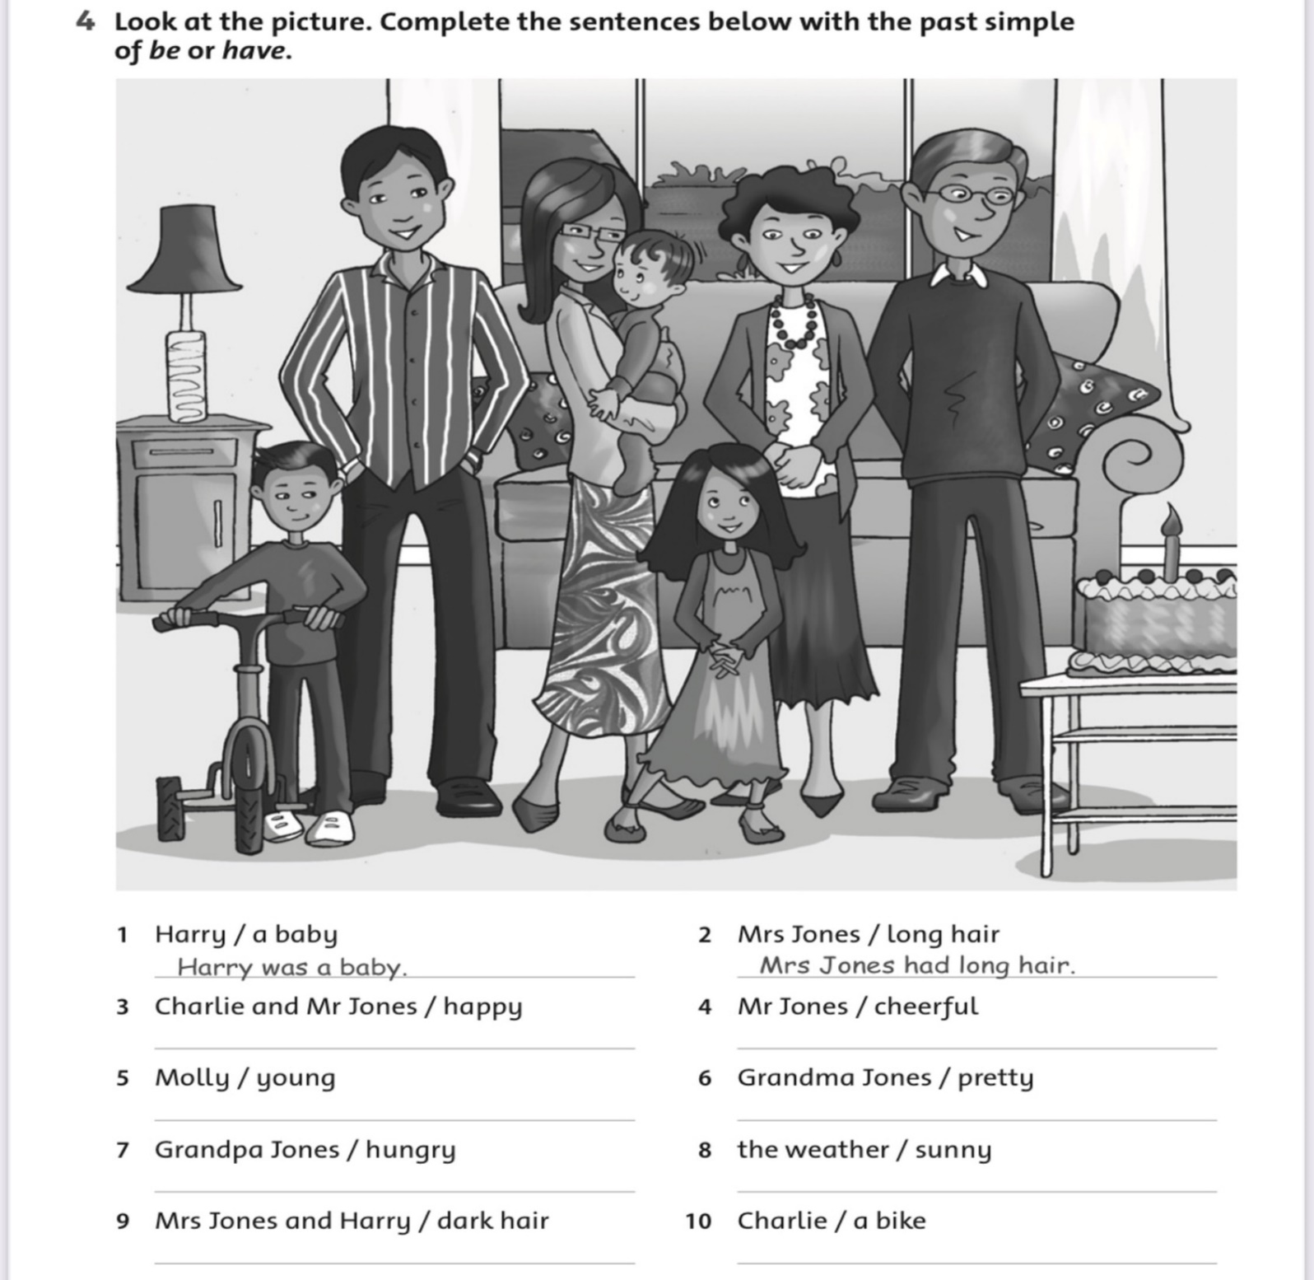
3.

4.
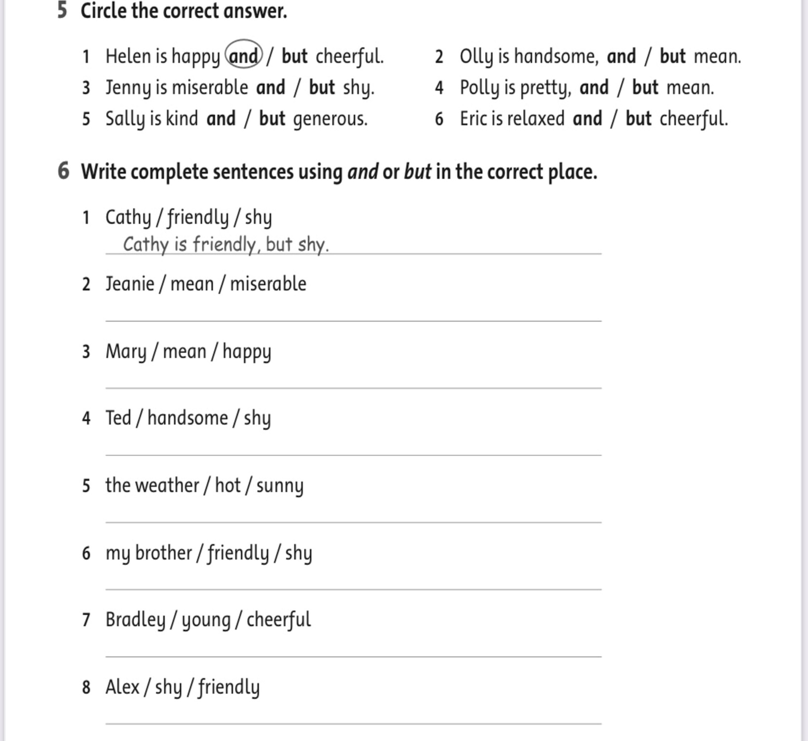

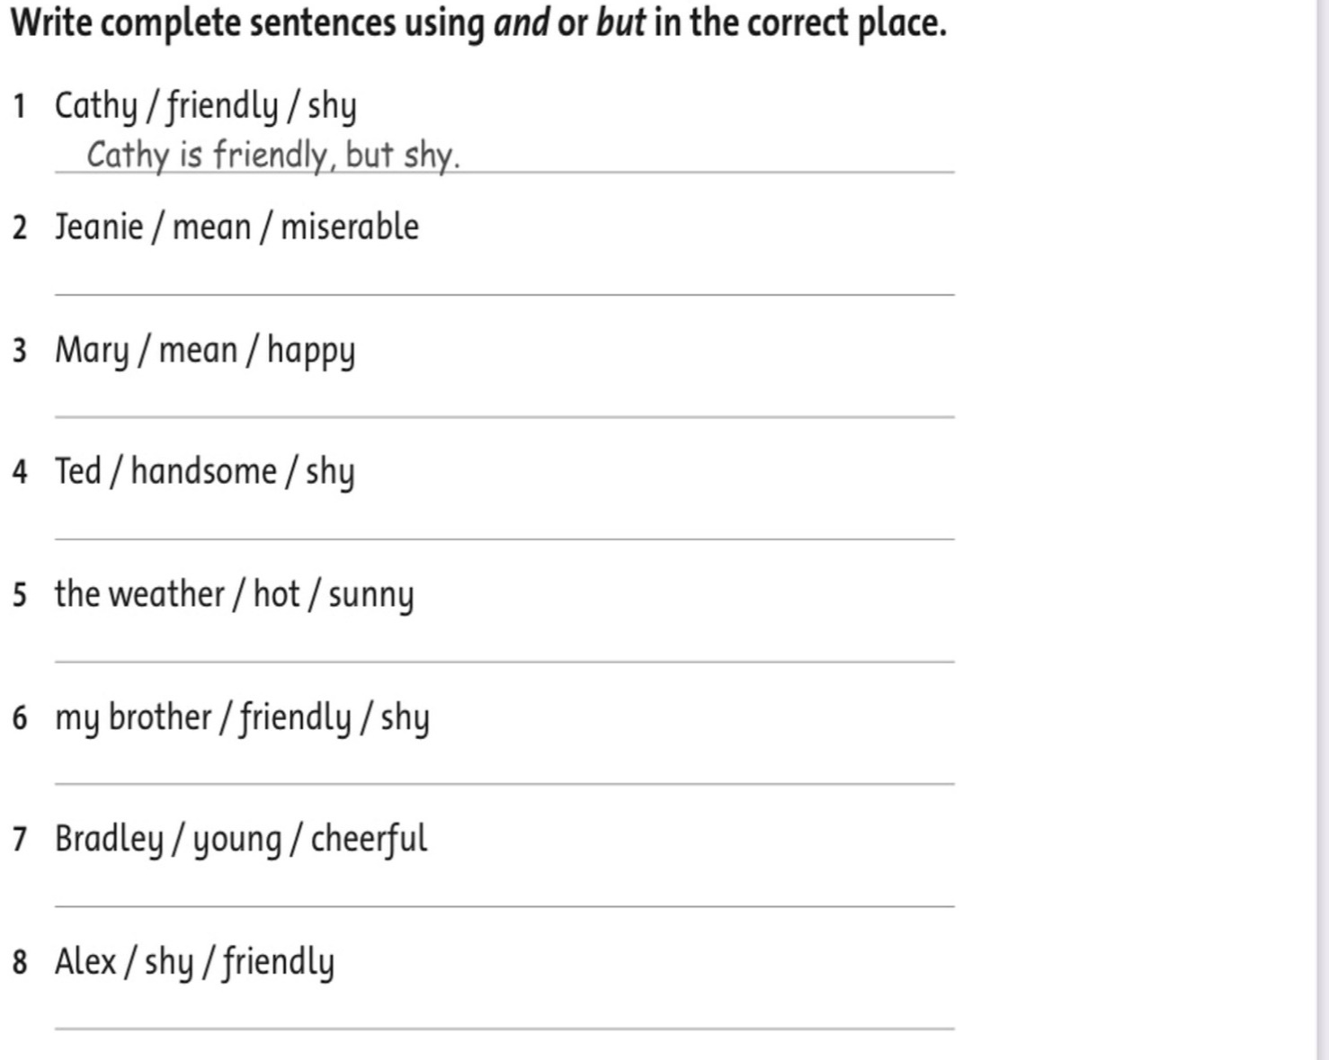
5.

ANSWER KEY ( REVIEW UNIT 12 )
1.Write sentences using past simple of (be).

- Rob wasn’t handsome.
- Chloe and Eric were clever.
- Eric and Mia weren’t friendly.
- Julia and Kate were pretty.
- Chloe was pretty.
- Rob was clever.
- Kate wasn’t clever.
- Eric wasn’t handsome.

2.Look at the picture of the Hill family when they were young. True or False? Write T, F

- T 2. T 3. F 4. T 5. T

3.Look at the picture. Complete the sentences below with the past simple of be or have.

- Harry was a baby.
- Mrs Jones had long hair.
- Charlie and Mr Jones were happy.
- Mrs Jones was cheerful.
- Molly was young.
- Grandma Jones was pretty.
- Grandpa Jones was hungry.
- The weather was sunny.
- Mrs Jones and Hary had dark hair.
- Charlie had a bike.

4.Circle the correct answer.
1. and 2. but 3. and 4. but 5. and 6. and

5.Write complete sentences using and or but in the correct place.
- Cathy is friendly, but shy.
- Jeanie is mean, and miserable.
- Marry is mean, but happy.
- Ted is handsome, but shy.
- The weather is hot, and sunny.
- My brother is friendly, but shy.
- Bradley is young, and cheerful.
- Alex is shy, but friendly.

