Name of student: _____________________________________

Class: 2/ ____

Name of teacher: Vo Thi Kim Ngan

Date:

WORKSHEET

UNIT 8: WHERE’ S GRANDMA ?

**1.**

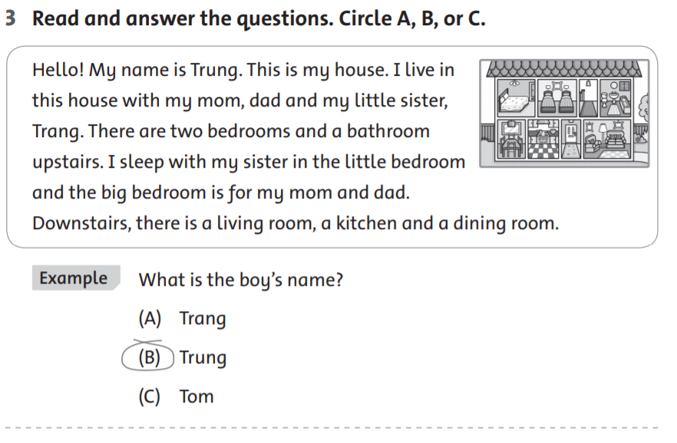

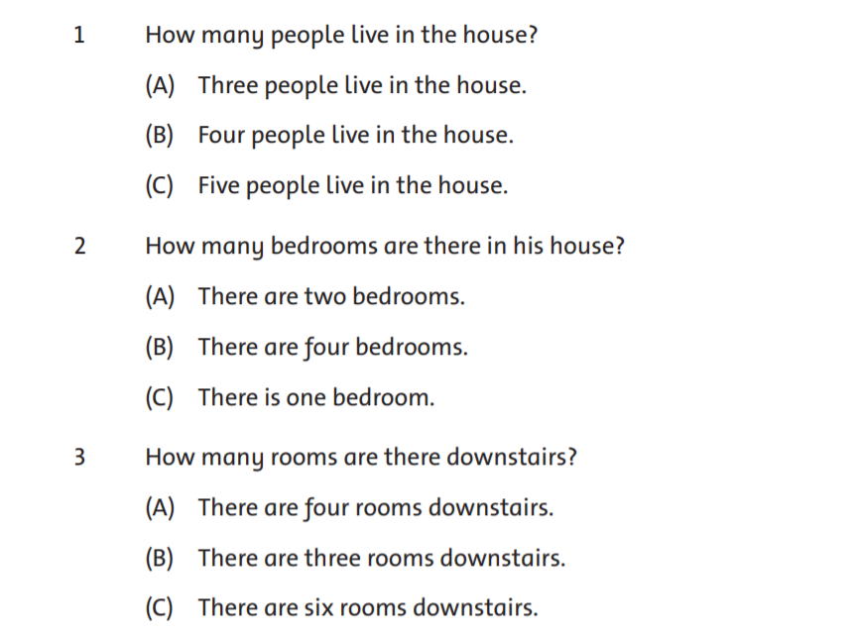

1. **Reorder the words to make correct sentences ( sắp xếp các từ sau thành câu hoàn chỉnh)**

*Ex: are / Where / mom and dad ?*

*Where are mom and dad ?*

=> __________________________________________________

1. in / living room. / Mom and dad / the / are

=> _____________________________________________________

1. Bella / Where’s ?

=>______________________________________________________

c. kitchen. / in / the / She’s

=> _____________________________________________________

d. Tom and Jerry ? / are / Where

=> _____________________________________________________

e. in / They’re / bathroom. / the

=> _____________________________________________________