**TEACHER’S NAME : NGUYEN THI NGOC HUYEN**

**STUDENT’S NAME : ………………………………………..**

**CLASS : 5/…**

**DATE : APRIL 27th-30th, 2020**

**UNIT 8- LESSON 5**

1. **Compare the bike, the car and the boat.**

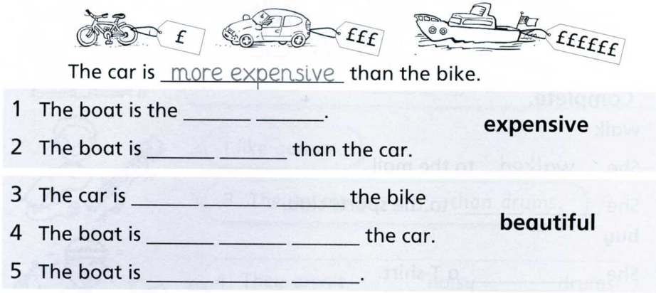

1. **Read the scores. Complete the sentences.**

