WORKSHEET. WEEK 26. GRADE 5

UNIT 11

1 Complete the words.

**1. 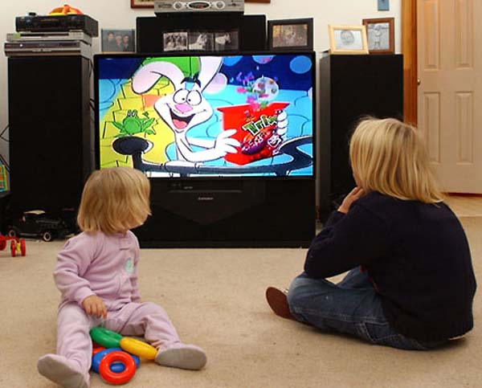 2. **

w_tch c_rto_n r_mot_ co_tro_

3.**** 4. 

TV _ho_ C_ll p_o_e

**2**. **Circle the odd one out.  
a** TVshow the news stadium channel  
**b** cartoon steal documentary the news  
**c** channel advertisement cartoon dangerous  
**d** stadium soccer game remote control

**3. Match.  
1** I use my MP3 player **a** to talk to a friend.  
**2** He bought a pizza **b** to watch the game.  
**3** She used her cell phone **c** to listen to music.  
**4** I turned on the TV **d** to change the TV channel.  
**5** We use the remote control **e** to eat for dinner.

example: **1.c**

**4. Complete the puzzle.**

**1** They make clothes in a …  
**2** They play sports championships in a …  
**3** You need a … to travel on a bus.  
**4** He doesn’t have any money. He’s …  
**5** I use my … to speak to my friends.  
**6** Did you watch the … about tigers?

|  |  |  |  |  |  |  |
| --- | --- | --- | --- | --- | --- | --- |
| **F** |  |  |  |  |  |  |
| **S** |  |  |  |  |  |  |
| **T** |  |  |  |  |  |
| **P** |  |  |  |

|  |  |  |  |  |  |  |  |  |
| --- | --- | --- | --- | --- | --- | --- | --- | --- |
| **C** |  |  |  |  |  |  |  |  |

|  |  |  |  |  |  |  |  |  |  |
| --- | --- | --- | --- | --- | --- | --- | --- | --- | --- |
| **D** |  |  |  |  |  |  |  |  |  |

|  |
| --- |
|  |

**5. Complete the sentences.**

**How once three often every twice**

**a.** They go on holiday  **once**  a year.  
**b.** How_________do you watch TV?  
**c.** We watch cartoons_________ day.  
**d.** I brush my teeth _________ a day.  
**e. _________** often does he watch the news?  
**f.** We watch movies ____________ times a week.