**WEEK 25**

*1. Read and match.*

|  |  |
| --- | --- |
| a. What is your name ? | 1.Yes , it is . |
| b. How old are you ? | 2.My name is Rosy. |
| c. What color is it ? | 3. It is a desk. |
| d. What is this ? | 4.I’m six years old. |
| e. Is it a robot ? | 5. It is green. |

*2. Find the mistakes and correct them.*

It is a **~~plane~~**. 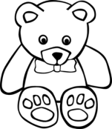=) **teddy bear**

It is an robot. 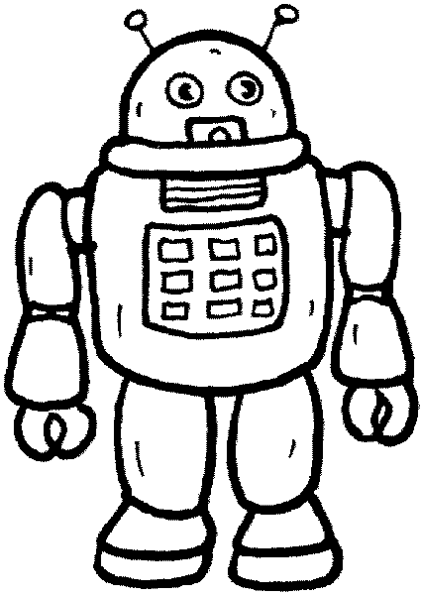=) _________________________

It are a balloon . 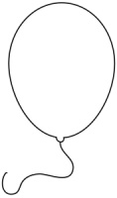=) _________________________

It is a pupet. 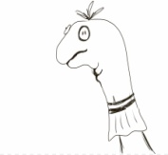=) _________________________

It is a planes. 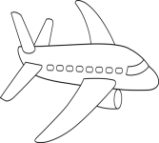=) _________________________

It is an balloon . =) _________________________

*3. Write the missing letter.*

|  |  |  |  |  |  |
| --- | --- | --- | --- | --- | --- |
| Káº¿t quáº£ hÃ¬nh áº£nh cho HORSE  clipart black and white | Káº¿t quáº£ hÃ¬nh áº£nh cho GIRL  clipart black and white | *Káº¿t quáº£ hÃ¬nh áº£nh cho guitar   clipart black and white* | *HÃ¬nh áº£nh cÃ³ liÃªn quan* | *HÃ¬nh áº£nh cÃ³ liÃªn quan* | Káº¿t quáº£ hÃ¬nh áº£nh cho ILL clipart black and white |
| **h** **o** rse | _ir_ | *_uitar* | *_ _t* | *_ _sect* | _ _ l |

*4.Write*

puppet ……………………………………………………………………………………………………

balloon

……………………………………………………………………………………………………

robot ……………………………………………………………………………………………………

plane ……………………………………………………………………………………………………

teddy bear ……………………………………………………………………………………………………

horse ……………………………………………………………………………………………………

hat ……………………………………………………………………………………………………

insect ……………………………………………………………………………………………………