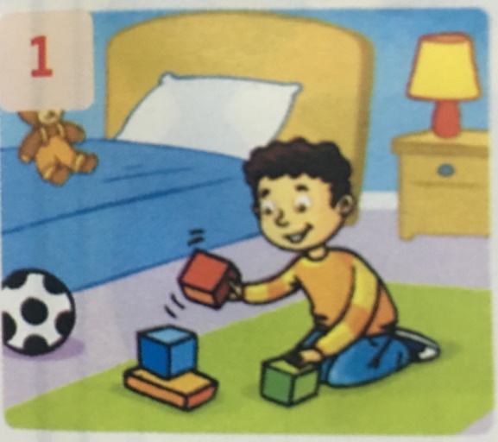 Look again and write

|  |
| --- |
| is are isn’t aren’t |

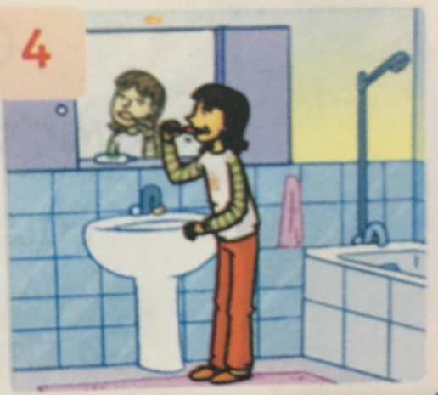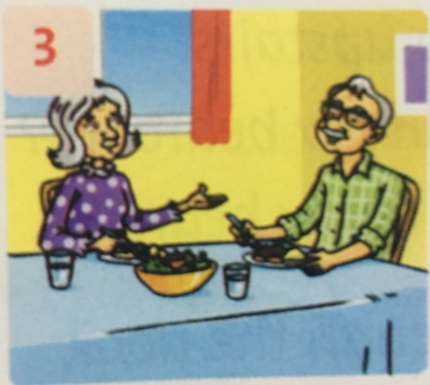

1/ …Is.. Billy in the bedroom? Yes, he is

2/ ………Mom and Dad in the bathroom? No, they …….

3/ ………. Grandpa and Grandma in the dining room? Yes, they……..

4/ ………Rosy in the bathroom? Yes, she……