Name: ______________________

Class: _______________________

**Circle the correct sentence:**

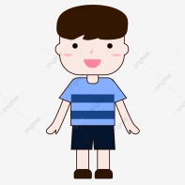

1. A . He’s happy.

B. He’s sad.

C. She’s happy.

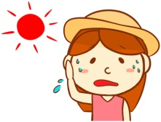 2. A. She’s hungry.

B. She’s hot.

C. He’s thirsty.



3. A. He’s cold.

B. He’s happy.

C. She’s hot.

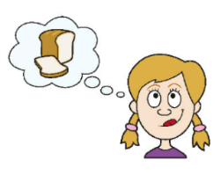

4. A. He’s hot.

B. She’s thirsty.

C. She’s hungry.

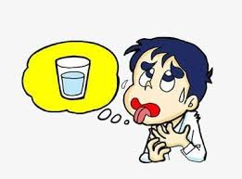 5. A. He’s hungry.

B. He’s thirsty.

C. She’s sad.



6. A. He’s sad.

B. He’s hot.

C. She’s thirsty.