**Bài tập**

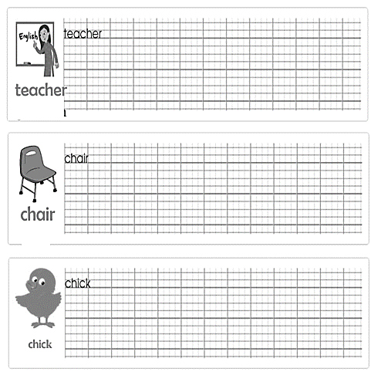

**I. Write v (yes) or x (no)**

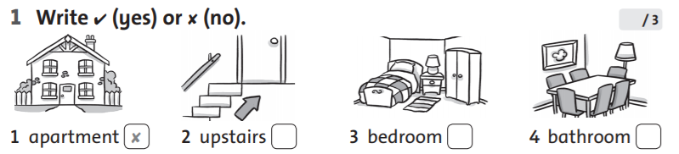

**II. Look at the pictures and write.**

|  |  |  |
| --- | --- | --- |
| Hình ảnh có liên quan | Kết quả hình ảnh cho eat at home clipart | Hình ảnh có liên quan |
| 1. Where are they? | 1. Where are they? | 1. Where is he? |
| They are in the living room. | ……………………………… | ……………………………… |
| Hình ảnh có liên quan | Hình ảnh có liên quan |  |
| 1. Where is she? | 1. Where is he? | 1. Where are they? |
| ………………………………… | ………………………………… | ………………………………… |

**III. Look and complete the sentences.**

a) Where is he ? He *………………* in the living room.

b) Is she in the kitchen ? Yes, she *………………*

c) *………………* are they ? They’re in the dining room

d) Are they in the garden ? No, they …………….

e) Where is your mom ? *………………* is in the bathroom.

f) Is your brother in the bedroom ? No , he *………………*

g) *………………* are Tony and John ? They are in the garden.

h) Where is she ? She is in *………………* bathroom.

i) Where is your grandma ? *……………* is in the bedroom

k) *…………….* they in the kitchen ? No, they aren’t.

l) Where is Tony ? He *………………* in the bathroom.