READING
- Look and read. Put a tick () or a cross (X) in the box. There are two examples. (5pts)
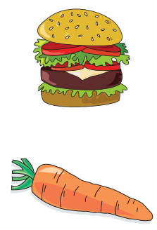

This is a burger. 

This is an orange. X

Questions:
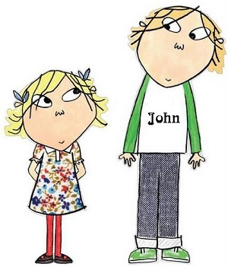

The boy is taller than the girl.



This is an elephant.


These are mangoes.



She could dance.



He couldn’t ride a bike.

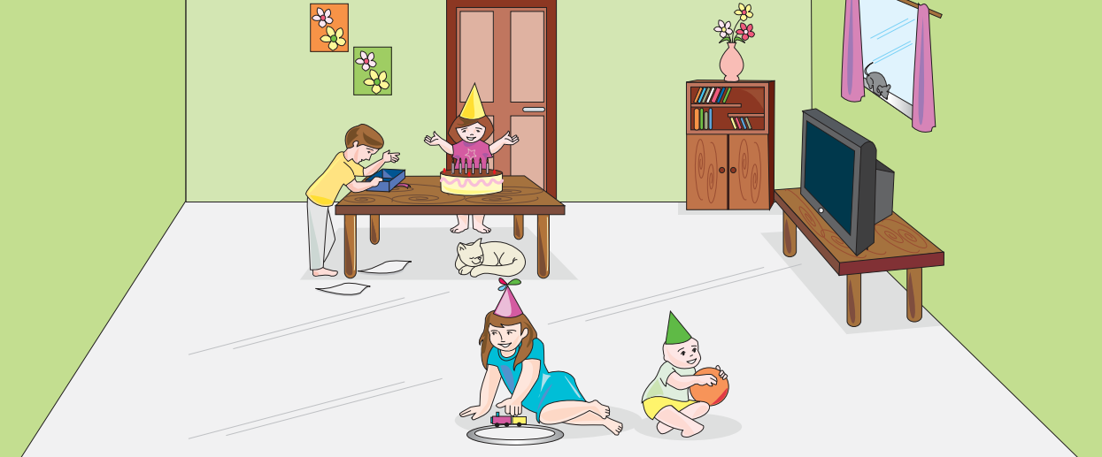
- Look and read. Write Yes or No. (5pts)

Examples:
There are four children in the room. Yes
There is a dog under table. No
Questions:
- There is a mouse in the room.
- A boy is playing with a train.
- There are some flowers on the bookcase.
- A baby is holding a ball.
- The children are watching television.

WRITING

- Look at the pictures. Look at the letters. Write the words. (4pts)
Examples:
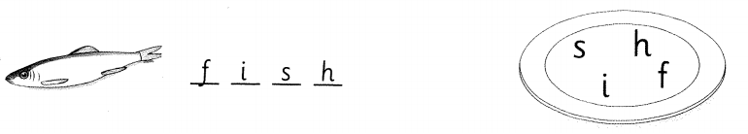

Questions:
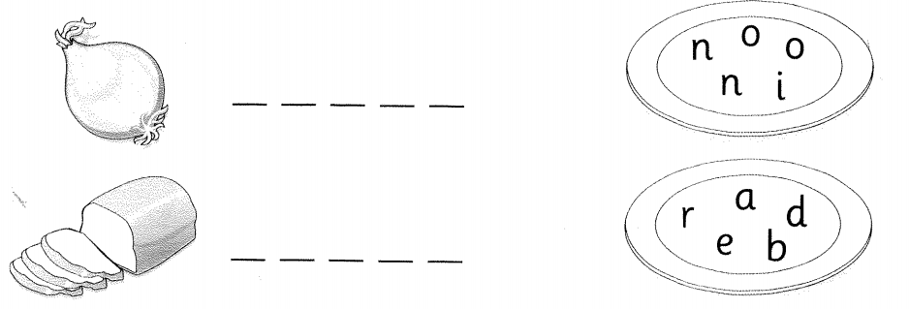

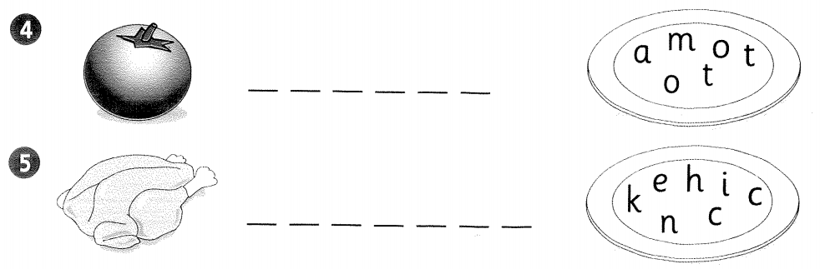

- Read the story. Choose a word from the box. Write the correct word next to number 1-4. There is one example. (4pts)

I live in a big city . My house is near a (1) _____________, a supermarket and a swimming pool. I sometimes go (2) ___________ with my mom at the supermarket on Sundays. I like buying toys and (3) _____________On Saturday mornings, I often go (4) _____________with my dad. We swim about an hour, then go home and enjoy lunch with my mom.
Living in a big city is funnier but it is noisier than living in a small town.

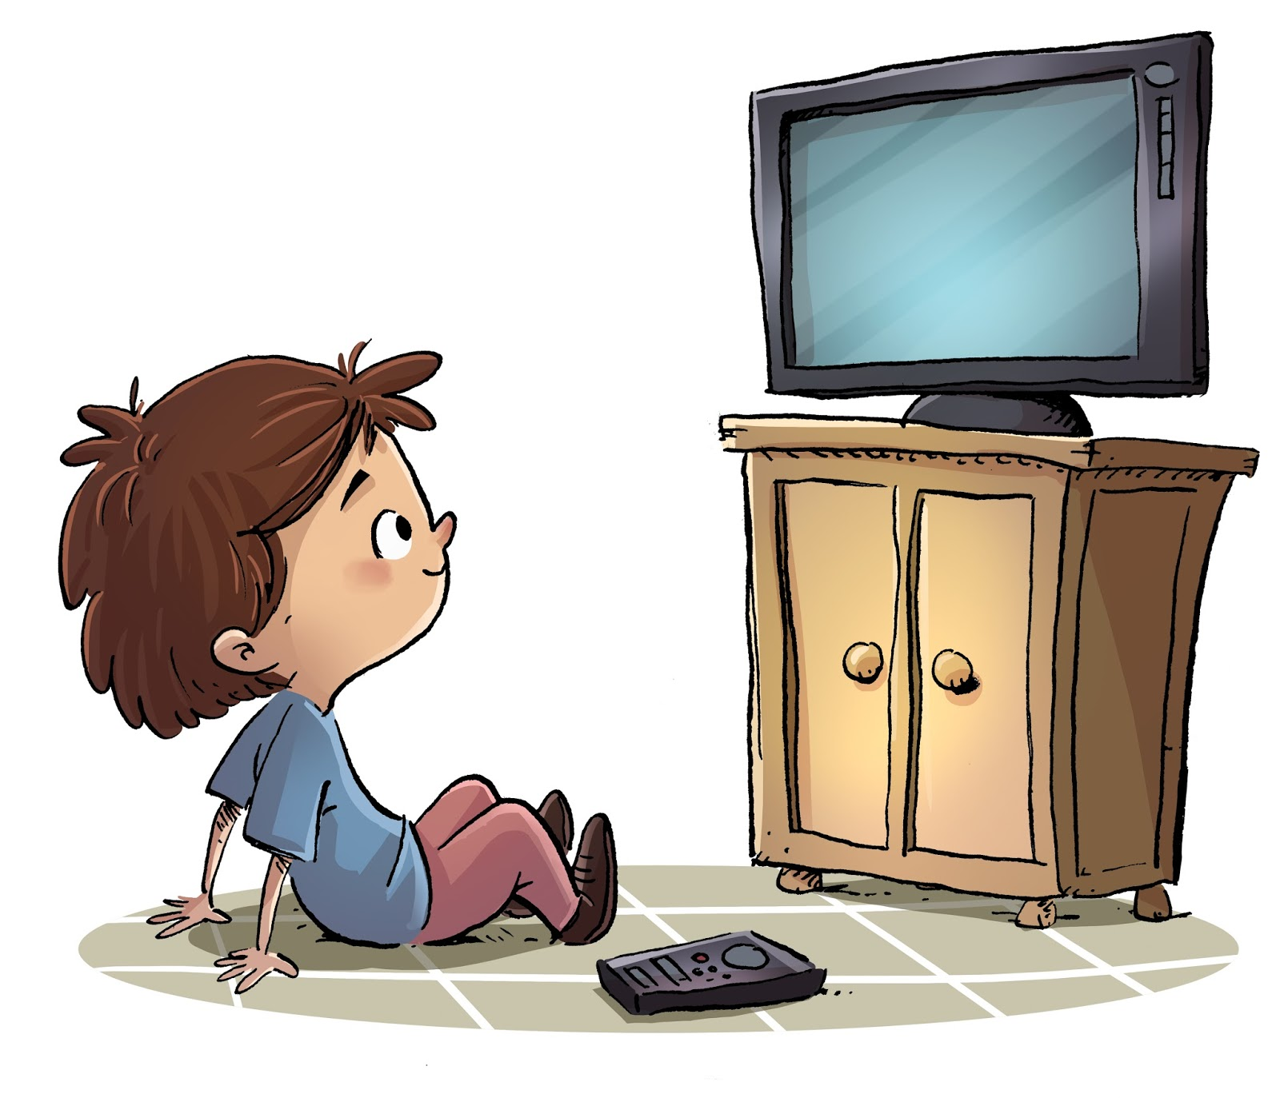





Watch TV bank swimming city ice-cream shopping

- Use the words in the box to complete the sentences. There is one example. (2pts)
Example:
Pat, Molly and Daisy played games at the party.
Questions:
- Bob and his friends ___________ to music.
- Mrs. Jones ___________party food.
- Charlie ___________TV.
- We __________ the birthday party at seven o’clock.

listened cooked
started played
washed watched

The end!
 ☺ 
ANSWER KEY
READING
I.Look and read. Put a tick () or a cross (X) in the box. There are two examples. (5pts)
1. 
2. X
3. X
4. 
5. X
- Look and read. Write Yes or No. (5pts)
1. No
2. No
3. Yes
4. Yes
5. No
WRITING
- Look at the pictures. Look at the letters. Write the words. (4pts)
- Onion
- Bread
- Tomato
- Chicken
- Read the story. Choose a word from the box. Write the correct word next to number 1-4. There is one example. (4pts)
- Bank
- Shopping
- Ice-cream
- Swimming
- Use the words in the box to complete the sentences. There is one example. (2pts)
- Listened
- Cooked
- Watched
- Started

