**Full name: …………………………**

**Class: ……..**

**Unit 11 In the museum**

**Lesson 1, 2, 3**

1. Look and count. Write the numbers.

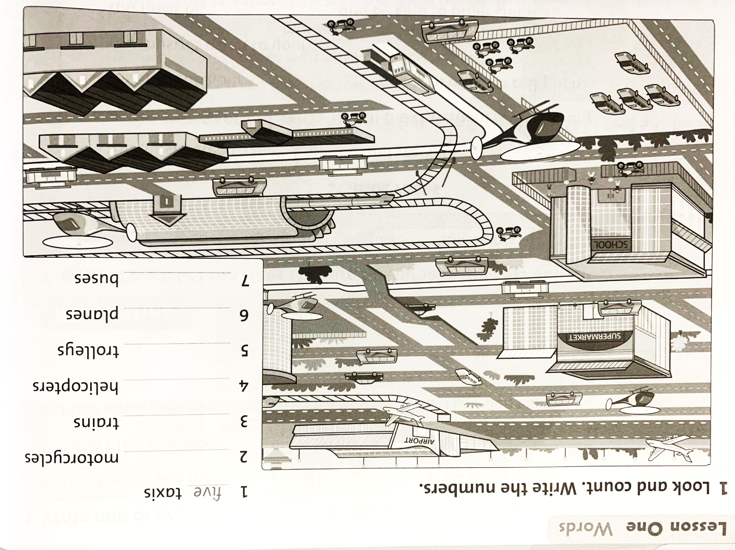

1. Look and read. Write **Yes** or **No.**
2. There’s a trolley near the airport. No
3. There’s a train at the station. _______
4. There’s a bus in front of the supermarket. _______
5. There’s a helicopter near the station. _______
6. There’s a bus next to the school. _______
7. There’s a taxi in front of the supermarket. _______
8. There’s a plane at the airport. _______
9. There’s a motorcycle in front of the school. _______
10. Write **there was** or **there were**.
11. There was a hotel in our town one hundred year ago.
12. ________________ trolleys in our town one hundred year ago.
13. ________________ some buses in our town one hundred year ago.
14. ________________ a park in our town one hundred year ago.
15. ________________ lots of bike in our town one hundred year ago.
16. ________________ a museum in our town one hundred year ago.
17. Write **There were**, **There was**, **There weren’t**, **There wasn’t**.

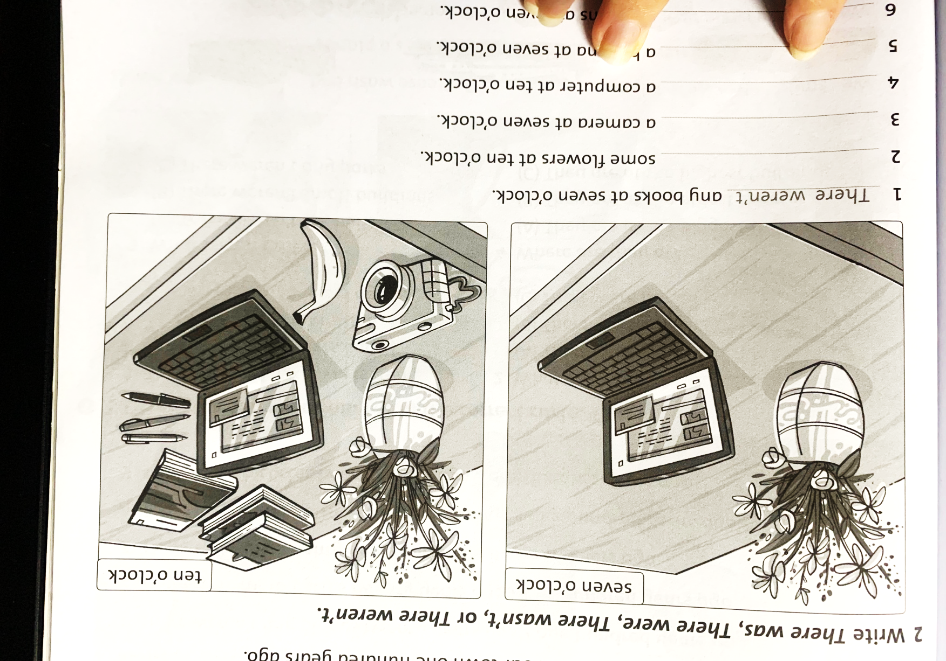

1. There were any books at seven o’clock.
2. _____________________ some flowers at ten o’clock.
3. _____________________ a camera at seven o’clock.
4. _____________________ a computer at ten o’clock.
5. _____________________ a banana at seven o’clock.
6. _____________________ any pens at seven o’clock.
7. _____________________ a camera at ten o’clock.