**TO HIEN THANH PRIMARY SCHOOL**

**UK ENGLISH PROGRAMME**

**LESSON OI - LEVEL 2A – WEEK 26**

**EXERCISE SHEET**

1. **Grammar point:**

|  |
| --- |
| What’s = What is  It’s = It is |

Tip:

**II. Exercise:**

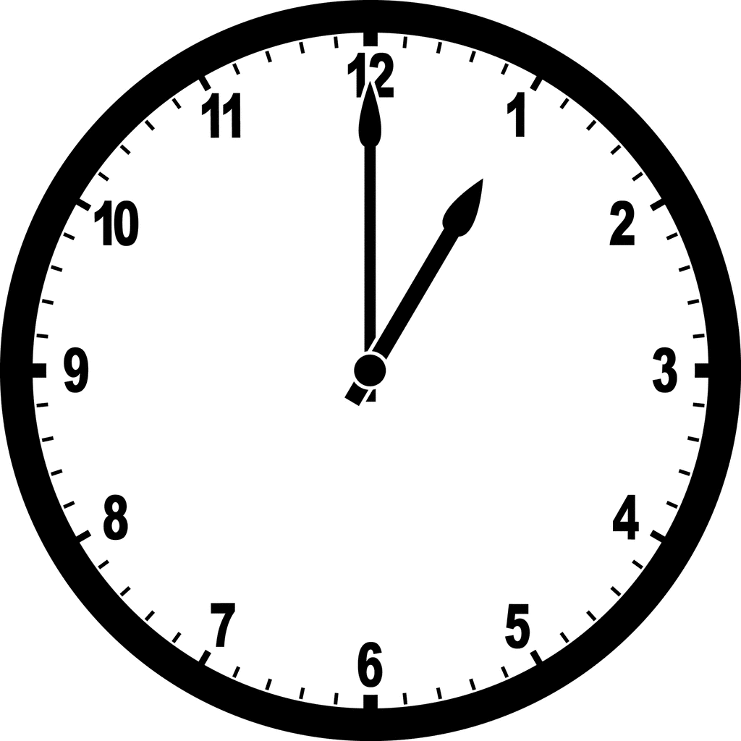**🖋 Write the words “**What’s **/** What is” and “It’s/ It is” **into the blanks:**

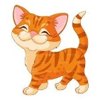1) _______ the time now? ____________________________.

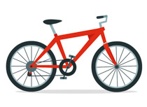2) _________that? _________________________.

3) _________this? _________________________.

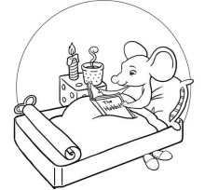4) ____________a baby dog called? ______________. p _ _ _ y

5) ___________on the bed?_________________________.

**🖋 Write one word in the blanks:**

Ex: It’s Sunday today. Bob is at home.

1. It’s_______ o’clock now.
2. Today it is__________ and bright.
3. Bob can hear the __________ singing.
4. Bob usually has some__________ and juice for breakfast.
5. Bob uses a__________ to eat.

**🖋 Fill in the blanks .**

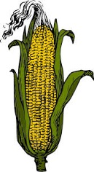

|  |  |  |  |
| --- | --- | --- | --- |
| Free Badminton Cliparts, Download Free Clip Art, Free Clip Art on ... |  | 78+ Milk Clipart - Cli... Clipart Milk | ClipartLook | Ex: You *have* corn and milk but you *play* badminton. |
| SPCOAB50 | Sunny Picture Clipart Of A Broken Big Pictures | HD ... | Download Free png Weather Clipart Snowy - Clip Art Black And White ... | Solo Support Services | Hot Weather ☀️ | It’s hot and _________ in summer but it is ________ in winter. |
| Free Badminton Cliparts, Download Free Clip Art, Free Clip Art on ... | Upcoming Swimming Information – ConnectEd@BrightonPS | 3,326 Bouncing Ball Stock Vector Illustration And Royalty Free ... | You play ________ and ________ but you go _________. |
| Coffee Clipart Images, Stock Photos & Vectors | Shutterstock | Cute Cartoon Eggs Clipart | สอนวาดรูป | Corn Clipart Free PNG Image｜Illustoon | You drink ________ but you _______ an egg and corn. |
| Best summer clip art black and white 16436 clipartion within ... | Supermarket Clipart Black And White | Letters Example throughout ... | Library of building a house vector stock black and white png files ... | You go to the _________ and the _________, but you __________ at home |
| Basketball black and white basketball clipart free black and white ... | Boy on roller skates.Children. — Stock Vector © Digital-Clipart ... | Boy Drowning in Swimming Pool Stock Illustrations, Images ... | You can _________ basketball and skate, but you _______ swim. |

**III. Writing:**

- join : tham gia

-

-

- noise : tiếng ồn

-

-

- coin : đồng xu

-

-

- voice : giọng nói

-

-

- bright : sáng ngời, rạng rỡ

-

-

- corn : bắp

-

-

- fork : cái nĩa

-

-

- roll a coin: lăn đồng xu

-

-

- coin race: cuộc đua lăn đồng xu

-

-

-Chúc các em làm bài tốt -

**ANSWER KEYS**

**🖋 Write the words “**What’s **/** What is” and “It’s/ It is” **into the blanks:**

1) What’s the time now? It’s 1 o’clock.

2) What’s that? It’s a cat.

3) What’s this? It’s a bike.

4) What’s a baby dog called? It’s called a puppy. p _ _ _ y

5) What’s on the bed? It’s a mouse on the bed.

**🖋 Write one word in the blanks:**

Ex: It’s Sunday today. Bob is at home.

1. It’s 8 o’clock now.
2. Today it is sunny and bright.
3. Bob can hear the birds singing.
4. Bob usually has some corn and juice for breakfast.
5. Bob uses a fork to eat.

**🖋 Fill in the blanks .**

1. bright – snowy
2. badminton – ball - swimming
3. coffee – eat
4. beach – supermarket – stay
5. play – can’t