Exercises
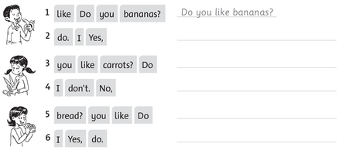
1 Order the words (sắp xếp lại câu).

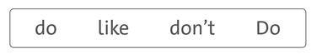
2 Write

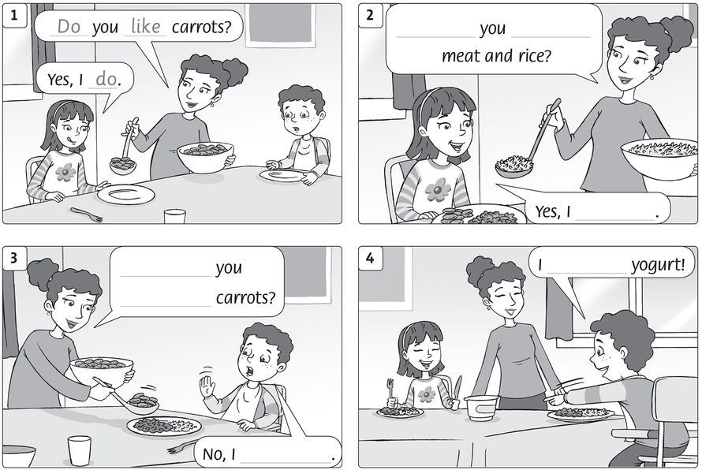

Answer key
1 Order the words
1 Do you like bananas?
2 Yes, I do.
3 Do you like carrots?
4 No, I don’t.
5 Do you like bread?
6 Yes, I do.
2 Write
Do
like

Do
like
don’t
like
do

